#### Capstone Project (CPRO306)

**Assessment 5: Systems Design and Implementation Plan**

#### **Project Title: Jot Bike Management System**

|  |  |  |
| --- | --- | --- |
| **Team Members** | | |
| **No.** | **Name** | **SID** |
| **1** | **Alyxandra Marie Sarmiento** | **K220411** |
| **2** | **Wangshu Tamang** | **K210810** |
| **3** | **Erna Halim** | **K221578** |
| **4** | **Hendra Lim** | **K220685** |
| **5** | **Thi Ngoc Quynh Ho** | **K220508** |

**Submission Date:** Week 9

Capstone Project (CPRO306) 1

**Project Title: Jot Bike Management System** 1

**1. Introduction** 3

**Project Overview** 3

**Objective of the Report** 3

**2. System Development Planning and Management** 3

**Project Planning** 4

**Risk Register** 4

**Resource Management** 4

**Timeline and Milestones** 5

**3. Teamwork Management** 5

**Team Roles and Responsibilities** 6

**Communication Strategies** 6

**Collaboration Tools Used** 6

**4. Business Requirements Elicitation** 7

**Requirement Gathering Process** 7

**Business Requirements Document** 7

**Stakeholder Analysis** 10

**5. System Architecture** 10

**6. Database Design** 13

**Database Schema Overview** 13

**Physical Layout and Structure** 13

**Tables, Keys, and Relationships** 13

**Entity-Relationship Diagram (ERD)** 14

**Database Design Tools Used** 15

**7. User Interface Design** 15

**UI Design Principles** 15

**Wireframes** 16

**User Journey** 49

**Chatbot UI and AI API Integration** 49

**8. Programming and Implementation** 49

**Code Overview** 49

**Backend Code** 49

**Package.json File** 56

**9. Conclusion** 57

**10. Feedback** 58

**11. Reference** 58

### **1. Introduction**

#### **Project Overview**

Jot bikes is a leading Australian company that specializes in rental and sales of electric bikes and scooters. This project, Jot Bikes management system, aims to create a web-based solution to support the operations of jot bikes. As the business is growing rapidly, its current manual processes have become inefficient, leading to booking errors, poor inventory control, and limited customer support. Hence, the focus is to bring all the core functions such as bookings, sales, inventory, and vendor management into one centralised platform. It supports three types of users which are customers, vendors and admins, where each of them has a specific role.

* Centralised System: Develop a unified platform to manage electric bike inventory, rental/sales records, customer accounts, and vendor listings efficiently.
* Online Booking & Payment: Allow customers to check availability, make bookings, and complete secure payments through the website.
* Customer Relationship Management (CRM): improve customer experience with features like booking history, automated email/SMS notifications, and feedback collection.
* Vendor Management: Provide vendors with tools to upload and update listings, track bookings, and manage availability in real time.
* Data Analytics & Reporting: Equip administrators with dashboards and reports to monitor sales, rental trends, customer usage, and vendor performance.
* Security and Compliance: Ensure data privacy and protection by following Australian privacy laws and web security standards (e.g., OWASP, OAIC).

#### **Objective of the Report**

This report has documented the System Design & Implementation Plan (SDIP) for the Jot Bikes Management System (JBMS). The report demonstrates how the proposed solution meets five evaluation criteria:

1. Planned & Managed Development – evidence of a formal SDLC, risk plan, timeline and resource matrix
2. Complete Business Requirement – a verified Business Requirement Document and traceability to functional and non-functional specs
3. Robust Architecture & Database Design – MERN stack layers mapped to all data entities and services
4. Task-focused UI/UX – wireframes and design rule showing each user can accomplish every core task
5. AI-ready interfaces – clearly-marked UI entry points for the AI chat box that is still currently under development

### **2. System Development Planning and Management**

#### **Project Planning**

Effective project planning plays a crucial role in the development of Jot Bikes Management Systems (JBMS). Here, we undertake the planning stage in a number of critical steps Project Management Institute (2021).

* Define Project Scope: The first step is to clearly indicate the objectives of JBMS. This includes managing bike inventory, maintaining rental/sales records, posting advertisements for vendors, and keeping track of customers. The boundary of this scope will also set limits on the project, so that all parties concerned with its outcome have a common grip on what has been decided.
* Requirements Gathering: To guide JBMS development, information taken from all relevant parties will be invaluable for the project. Sources include Jot Bikes managers, vendors and customers. Functional requirements might include things like user registration; booking management; payment processing. Non-functional requirements are any aspects which cover system performance, safety of data and compliance with data protection regulations.
* Risk Assessment: Identifying possible risks is a key part of project planning. For JBMS it will raise issues such as data breaches, system downtime and the troublesome issue of user adoption. A thorough risk assessment involves examining the likelihood and impact of each risk, followed by strategies to mitigate it.
* Budgeting: Establishing a complete budget is necessary for the successful completion of JBMS. This will include all costs incurred by the project, such as its development, hosting, maintenance and user training. By prudently apportioning the project's resources and monitoring expenditure, the project team can ensure that favours remain financially feasible.

#### **Risk Register**

|  |  |  |  |  |
| --- | --- | --- | --- | --- |
| ID | Risk | Likelihood | Impact | Mitigation |
| R-1 | Payment gateway version change | M | H | Upgrade to the new version |
| R-2 | MongoDB Atlas free tier limit | M | M | Upgrade to the paid plan |
| R-3 | PII breach | L | H | OWASP ASVS checks |
| R-4 | Regulatory non-compliance | L | H | Map policy toward the regulation |
| R-5 | Frequent Git merge conflict | M | L | Take turn reviewing |

#### **Resource Management**

Making sure that the JBMS project has the staff and assets it needs to accomplish its objectives requires at least some resource management. Resource management's most important aspects include:

* Resource Reallocation: For example, JBMS development requires a diverse team of skilled engineers. The developers, project managers, and QA/Tester all necessary resources necessary will be provided for each task; however, each resource offloads work according to his level of interphase expertise. In this example, front-end engineers are to be hired during the UI design phase, but back-end points programmers will also take some responsibility backing things up in an API development.
* Resource Tracking: It is vital to put a system into place for following resource usage and availability. This tracking will enable the early detection of all sorts of bottlenecks or shortages in project resources: things can be done now about an integrated team approach that would otherwise be either impossible or too difficult for people working separately. Project management tools can provide real time information on how the team's workload is made up and where.
* Training Programs and Development of Skills

Since the JBMS project is built on modern technology such as the MERN stack, it is important to identify any training needs that its participants may have. Providing training sessions in the relevant technologies and tools will make sure that all team members have the skills necessary for efficient and productive functioning on-site at JBMS. This investment in training will improve team performance and accordingly the results of the project.

#### **Timeline and Milestones**

Setting up a schedule for the entire project as well as various milestones along the way is vital in order to keep track of progresses and make certain there is no lag in JBMS plays.

* Project Timeline: A Gantt chart will display the project schedule – key points include gathering requirements, experimentation and deployment. This visual representation will help the team understand as a whole the timelines of different tasks and interdependencies between them.
* Milestones: Achievements are important mileposts that mark significant progress in the project. For JBMS, essential nodes may include completion of the user interface design; successful integration with payment gateway systems; validation and acceptance testing (UAT) by users. Attainment of these milestones will make it easier to maintain team morale and concentration upon goals
* Adjustments: Flexibility is crucial as unforeseen obstacles will emerge throughout the project. Project managers will be ready to adjust schedules and markers according to progress, feedback from stakeholders, and exposure of risks. Regular reviews of the timeline for the project will ensure that all team members continue on course and are able to change direction when needed.

### **3. Teamwork Management**

#### **Team Roles and Responsibilities**

Defining clear roles and responsibilities within the JBMS development team is essential for effective teamwork. This will involve:

* Role Definition: Each team member will have a clearly defined role, such as project manager, frontend developer and backend developer, UI/UX designer and quality assurance tester. This will help to ensure accountability and streamline communication within the team.
* Responsibility Assignment: To further clarify responsibilities, a RACI (Responsible, Accountable, Consulted, Informed) matrix will be used. This matrix will outline who is responsible for each task, who is accountable for the overall outcome, who needs to be consulted along the way, and who should be kept informed. This structured approach prevents misunderstandings and ensures that everyone is aware of their contributions to JBMS project.
* Performance Evaluation: Establishing criteria to evaluate team member performance is not only a challenge but also an essential step in creating accountability and continuous improvement within JBMS. Regular performance reviews will be conducted to evaluate individual contributions, identify areas for growth, and give constructive feedback. This will not only enhance team dynamics but also promote professional development for the members of our team.

#### **Communication Strategies**

Effective communication is the backbone of successful teamwork. For JBMS, the following strategies will be implemented:

* Regular Meetings: The team will see regular check-ins, such as morning stand-ups and weekly sprint reviews (Beck 2001). These are meant to be times for the team to share updates, talk about challenges and get aligned on priorities. With open communication lines, the team is able to solve any issues in real time and get ahead of schedule.
* Feedback Mechanism: We will also establish mechanisms for feedback and provide multiple feedback channels, such as a suggestion box and weekly messages from management to members who have made suggestions in the past week. These efforts will help members to better understand their collaborative efforts and prevent mistaken credit.
* Documentation: Wrap up documentation in a meeting of the managers, the communique went out to make sure that everyone knew the meeting had taken place and what had been decided next steps for J profiles.

#### **Collaboration Tools Used**

By adopting appropriate collaboration tools, team cooperation as well as project efficiency can be improved greatly. For JBMS, it will be used:

* Project Management Tools: Things like Jira and Trello will serve as task management tools on JBMS. Here, these platforms will allow managers to design and assign tasks and monitor progress. With these aids, the team can keep things organized and their goals in focus.
* Communication Tools: Tools like Microsoft Teams or Slack serve as real-time platforms for communication among team members. These platforms allow for instant discussions, file sharing and integration with other tools to enhance utmost speed in getting a word out. The result is greater cohesion within a team.
* Revision Control System: GitHub will be employed to facilitate coding collaboration and version management. Multiple people within our group can work simultaneously with JBMS, its system will prevent conflicts between them. This keeps development from being bogged down in local logjams where single people are working on isolated stretches. Regular code reviews and pull requests are the order of the day on JBMS to ensure good code and provide opportunities for knowledge sharing among team members (Beck 2001).

### **4. Business Requirements Elicitation**

#### **Requirement Gathering Process**

* Assign Roles – RACI (Responsible, Accountable, Consulted, and Informed) matrix is implemented to ensure a clear understanding of the role and how it is interacted.
* Identifying Stakeholders – All key stakeholder is identified to ensure that their influence and interest are mapped accordingly.
* Gather and Documentation – Requirement are gathered from the initial JBMS project description which are consolidated into a draft Business Requirement Document (BRD) which list functional needs, non-functional targets and known constraints.
* Assumption and Requirement validation – The team reviews the draft BRD to uncover hidden assumption and test each item for feasibility, testability, and alignment with project objectives.
* Getting Approval – Once validated, the refined BRD is presented to the Product Owner and other key stakeholders for formal sign-off.
* Monitor Progress – Progress is tracked in weekly sprints, with outcomes and action items logged transparently on the team’s GitHub Discussion page.

#### **Business Requirements Document**

|  |  |  |  |  |  |
| --- | --- | --- | --- | --- | --- |
| **Project name: Jot Bikes Management System**  **Project Manager: Hendra**  **Date Submitted: 11/05/2025** | | | | | |
|  | | | | | |
| **Executive summary** | | | | | |
| This project aims to create a web-system that can streamline the internal operations of Jot bikes into single platforms. It will also address current inefficiencies to provide greater service and customer satisfaction. | | | | | |
| **Business Requirements** | | | | | |
|  | | | | | |
| **Functional Requirements** | | | | | |
| **ID** | | **Requirement Description** | | | **Priority** |
| FR1 | | Users can register, log in, and be assigned a role (Customer, Vendor, Admin) | | | High |
| FR2 | | Customers can search for available bikes by location, model, or price | | | High |
| FR3 | | Customers can make and confirm bookings with email notifications | | | High |
| FR4 | | Admins can manage users, monitor bookings, and access reports | | | High |
| FR5 | | Vendors can manage their listed bikes and update bike status | | | High |
| FR6 | | Customers can cancel bookings and submit feedback after use | | | Medium |
| FR7 | | Admins can review and moderate customer feedbac | | | Medium |
| FR8 | | System keeps records of bookings and status changes for accountability | | | High |
|  | | | | | |
| **Non-functional Requirements** | | | | | |
| **ID** | | **Requirement Description** | | | **Priority** |
| NFR1 | | The system should be available | | | High |
| NFR2 | | Secure login with password encryption and role-based access | | | High |
| NFR3 | | The website should work well on mobile, tablet, and desktop devices | | | High |
| NFR4 | | Sensitive data like passwords should be stored securely | | | High |
| NFR5 | | The system should be able to handle future growth in users and vendors | | | Medium |
| NFR6 | | Pages should load quickly (under 2 seconds in normal conditions) | | | High |
| NFR7 | | There should be alerts for system errors or suspicious activities | | | High |
| **Key Stakeholders** | | | | | |
| **Name** | | | **Project Role** | **Core Duties / Interest** | |
| Hendra | | | Project Manager | Schedule sprints, allocate tasks, liaises with JBMS, signs off on technical scope | |
| Erna | | | Lead Developer | Developed the website, build node, integrates MongoDB Atlas & Stripe | |
| Thi | | | UI/UX Lead | Produce wire-frames, drive usability testing, approve overall design | |
| Wangshu | | | Vendor Liaison | Collect vendor requirement and BDM (Business Development Manager) to increase the total vendor. | |
| Alyxandra | | | Data Analyst | Prepare inventory and sales report | |
| JBMS Team | | | Business Owner | Approve the final go-live | |
| **Project Constraint** | | | | |
| 1. Time: The project must be completed within the 11-week semester as on week 12 it will be the final presentation. 2. Human Resources: All work is distributed between 5 student whose availability are limited due to other commitment and subject. 3. Technology: The JBMS system totally run on a no cost plans such as GitHub free, MongoDB Atlas free, Stripe test mode. Which is purely for display purpose. 4. Compliance: The system must satisfy the local regulation such as Australian Privacy Act 1988 5. Long-Term Sustainability: After hand-over, the JBMS system would need to upgrade to paid hosting. | | | | |
| **Cost Benefit Analysis** | | | | |
| 1. Development labour (student project): $0 2. Tools and Resources: $0 3. Domain name + SSL cert: $100 per year 4. Ongoing Maintenance: $35000 per year for a part time developer 5. Post-launch hosting: $500 - $1000 for 24/7 public site and regular backup | | | | |

Business requirement document

Functional requirement  
These describe what the system should do to support the business operations of Jot Bikes.

* Users should be able to register, log in, and be assigned roles (Customer, Vendor, Admin).
* Customers should be able to search for available bikes by location, model, or price.
* Customers should be able to make and confirm bookings with automated email notifications.
* Admins should be able to manage users, bookings, and generate system reports.
* Vendors should be able to manage their bike listings and update bike status (e.g., available, rented).
* Customers should be able to cancel bookings and provide feedback after using the service.
* Admins should be able to review, approve, or moderate customer feedback.
* The system should log and maintain records of all bookings and changes in status for traceability.

Non-functional requirements

* The system should maintain high availability.
* User login should be secured with encrypted passwords and role-based access control.
* The platform should be fully responsive and work smoothly on mobile, tablet, and desktop devices.
* All sensitive data (e.g., passwords, personal details) must be securely stored.
* The system should be scalable to handle growth in user base and vendor participation.
* Website pages should load within 2 seconds under normal network conditions.
* The system should generate alerts for system failures or suspicious activity (e.g., multiple failed logins).

#### **Stakeholder Analysis**

|  |  |  |  |  |
| --- | --- | --- | --- | --- |
| **Stakeholder** | **Role** | **Influence level** | **Impact level** | **Key needs** |
| Customers | Use the platform to search, book, and rent bikes. | Medium | High | Easy to use interface, secure payment, reliable booking and cancellation |
| Vendors | List and manage bike inventory, monitor rental activity. | High | High | Efficient inventory control, booking updates, customer communication tools. |
| Admins | Oversee the entire platform, manage users, vendors, and monitor operations. | High | High | Full system access, reporting tools, user and content moderation capabilities. |
| Project Team | Develop, implement, and maintain the system. | High | Medium | Clear requirements, access to user feedback, structured timeline. |
| Business Owners | Oversee commercial aspects, investments, and business growth strategy. | High | High | Business performance insights, ROI visibility, customer satisfaction metrics. |
| IT Support Staff | Provide technical support and ensure system reliability. | Medium | Medium | System documentation, uptime monitoring, security tools. |

### **5. System Architecture**

|  |  |
| --- | --- |
|  |  |
| **Architectural Design Overview** | The system architecture of the JBMS is designed in mind to provide all the required functionality, while also ensuring that the non-functional objectives such as scalability, security, maintainability, and performance are being met. While the main system is up and running, there is a lot of details that need to be fine-tuned to meet the non-functional requirement. This architecture adopt. A modular and layered design based on the MERN stack – MongoDB, Express.js, React.js, and Node.js. This will enable full-stack JavaScript development and seamless communication between front-end and back-end components, while also creating a room for future expansion (Evans 2003). |
| **System Components** | This architecture has been designed to support:   * Centralized inventory and booking management for bikes and scooters * Role-based access control for Admins, Vendors, and Users * Real-time data interaction and responsiveness across various devices * Secure user authentication and encrypted data storage * Flexibility, rapid development, and ease of maintenance, while also aligning with industry standards for modern web application |
| **Technology** | * Frontend: React.js and Tailwind CSS has been chosen to provide responsive and support dynamic data binding which enable user to browse products, make bookings, and view dashboards Meta (n.d.). * Backend: Powered by Node.js and Express.js it exposes RESTful API endpoints for all core operations including user authentication, product management, booking processing, and payment handling. * Database: MongoDB hosted via MongoDB Atlas has been selected for this case, as collection are structured in a document-oriented schema suitable for flexible and scalable data storage which support users, bookings, feedback, and product listings. * Security: This is still Work in Progress, but the team is trying to implement AES-256 encryption for data at rest, bcrypt for password hashing, JWT for session management and HTTPS for data in transit (OWASP 2024). * Deployment: The JBMS frontend is deployed in Vercel, which offers seamless integration with React application for fast, scalable static site hosting. The backend API is hosted on Render, which enable automatic redeployment on code changes with minimal configuration. * Version Control: GitHub is used for version control, but continuous integration/deployment (CI/CD) is currently handled manually through commits and push-triggered redeployments on Vercel and Render platforms. |
| **Functional Requirements** | * User registration, login, and profile management * Product browsing with filters and search * Online rental and sales booking with secure payment processing * Real-time vendor and admin dashboards * Feedback and review submissions * Notification and reminder system |
| **Non-Functional Requirements** | * Scalability: modular design and cloud-hosted backend/database support horizontal scaling * Security: encrypted communication, secure storage, and access control enforced * Maintainability: code is structured using components and API separation for easier updates * Performance: Asynchronous operations and optimized data queries reduce response time * Availability: Cloud deployment ensures high uptime and reliability * Responsiveness: Tailwind CSS and React enable responsive layout. * Compliance: Aligned with OWASP, NIST, and Australian Privacy Act 1988 standards |

**Architecture Diagram**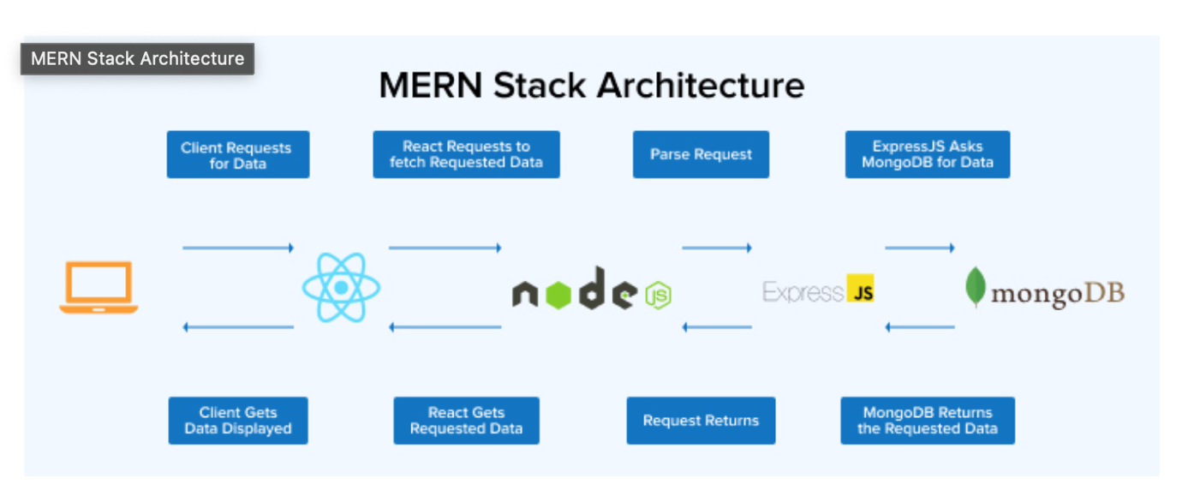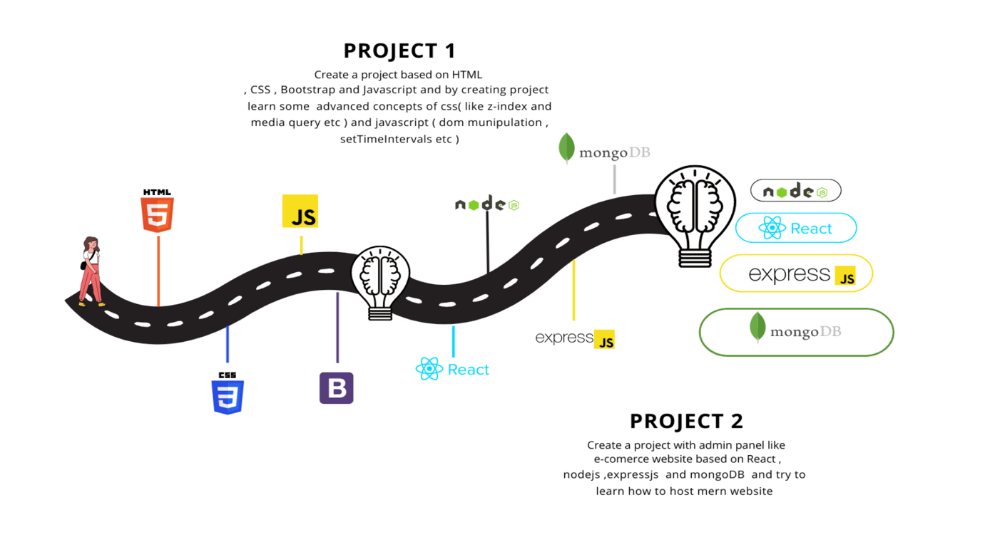

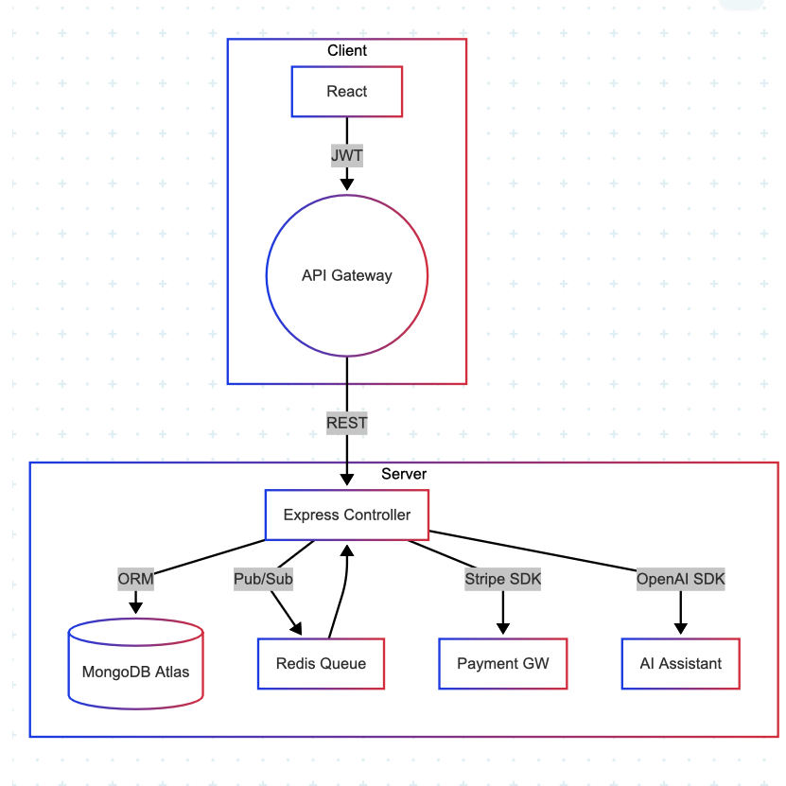

### **6. Database Design**

#### **Database Schema Overview**

The JBMS data model is built on a single MongoDB Atlas free-tier cluster (*MongoDB Courses and Trainings | MongoDB University* 2025). It comprises of seven core collection: user, categories, products, bookings, rental Agreements, transactions, and feedback. The schema has been made simple to fit the Atlas free-tier cluster (512 MB RAM, 100 conns).

#### **Physical Layout and Structure**

* Single database: JBMS
* Collections: 7 (core) + 2log/auxiliary (audit, sessions)
* Replication: Built-in 3-node replica set (Atlas)
* Backup: Continuous cloud backup
* Sharding: Not required, but considered in future roadmap for multi-vendor growth

##### **Tables, Keys, and Relationships**

|  |  |  |  |
| --- | --- | --- | --- |
| No | Collection & Purpose | Key Fields | Notes/Constraint |
| 1 | Users – admin, vendor, customer | _id, username (unique), email (unique), passwordHash, isAdmin, isVendor, createdAt | Email indexed for login; isVendor=true gets access to vendor dashboard |
| 2 | Categories – buy, rent | _id, name (unique) | Allow admin to add different brand of bike |
| 3 | Products – bike rent/sale | _id, name, brand, price, salePrice, category->categories, image, vendor->users, countInStock, size, color, rating, numReviews, createdAt | Compound index {vendor, price} accelerates vendor listings |
| 4 | Bookings – each rental event | _id, user->users, product->products, startDate, endDate, status, totalPrice, createdAt | Unique compound {product, startDate, endDate} to prevent double booking |
| 5 | Rental agreements – signed PDF & terms | _id, booking->bookings (1-to-1), embedded customer, embedded bike, rentalTerms. {startDate, endDate, totalPrice}, pdfUrl, status, createdAt | Booking indexed unique |
| 6 | Transactions – Stripe payments | _id, user->users, items[ { *product*, name ,qty, price}], vendor->users, paymentMethod, paymentResult, subtotal, tax, total, IsPaid, paidAt, type, bookingId->bookings, createdAt | Index {vendor, createdAt} for vendor revenue reports |
| 7 | Feedbacks – post-ride reviews | _id, user->users, type, subject, message, status, priority, category, attchments [], createdAt | Triage queue needs {status, priority} index |

#### **Entity-Relationship Diagram (ERD)**

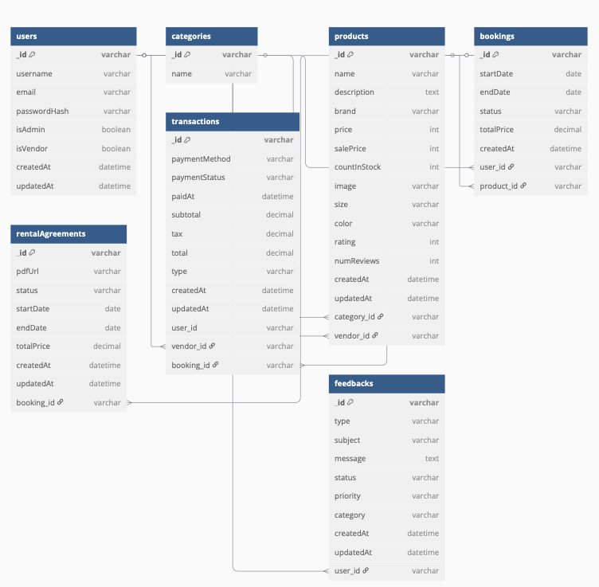

#### **Database Design Tools Used**

* MongoDB Compass – interactive schema design and sample-data validation
* Mongoose 6 – schema enforcement, ref integrity, and pre-save hooks for auto timestamps
* DBDiagram.io – quick ERD sketch

### **7. User Interface Design**

The UI (User Interface) design of the Jot Bikes Management System has been developed to ensure that all of the users (Admin, Vendor, and Customer) can navigate through the website easily and intuitively. The UI has been designed to be fully functional, clear, and accessible across different platform. By using React.js and Tailwind CSS for a responsive modern layout. Each user role has a custom dashboard, tailored to the specific features and actions relevant to the role, such as product management, bookings, user feedback, and payments.

To support intelligent user assistance, the system will also be integrating AI API functionality, which will include a chatbot embedded into the website. This chatbot will aim to provide support for tasks such as booking assistance and answering frequently asked questions.

Overall, the UI is structured to facilitate end-to-end task completion, reduce user errors, and provide real-time system feedback, while also incorporating modern AI elements to enhance usability and interactivity

#### **UI Design Principles**

The design of the JBMS user interface follows the industry-standard UI/UX principles (Kopp, Baumgartner & Kinkel 2020) to ensure that the system is intuitive, accessible, and consistent for all user types. These principles were applied throughout the development process to streamline task completion, reduce cognitive load, and improve user satisfaction.

* Clarity: Ensure that the system layout is kept simple and clean. Paired up with meaningful labels, intuitive icons and visual hierarchy these will allow users to easily identify where to perform actions such as bookings, product management, or profile updates.
* Consistency: Ensure consistent placement of navigation bars, call-to-action buttons, and form fields.
* Responsiveness: The interface is built using Tailwind CSS grid and flex utilities, which enabled smooth adaptation to various device sizes such as laptops, tablets, and mobile phones.
* Efficiency: The system has been designed to reduce page reloads and enhance productivity.
* User Feedback: The system provides real-time confirmation messages, error highlights, and loading indicators to guide the user through every action. Such as successful booking will display a confirmation message on the top right.
* User Control: All critical actions can be managed only through admin, this ensure the RBAC.

These principles ensure that the JBMS UI is not only visually modern, but also functional, inclusive, and scalable as the system grows in complexity or user base.

### **Wireframes**

The wireframe has been designed using Figma to enhance the visualization, and currently is the best tool out there in the market to create the prototype.

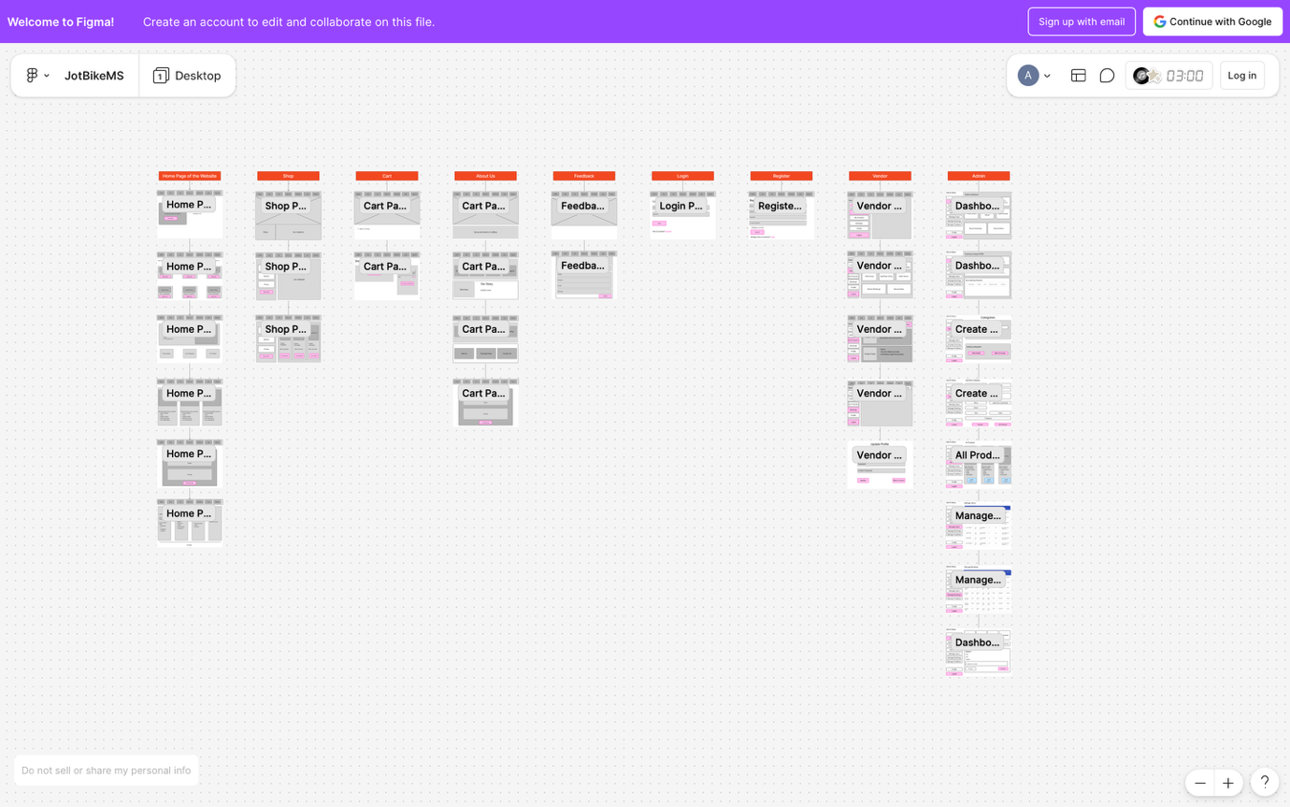

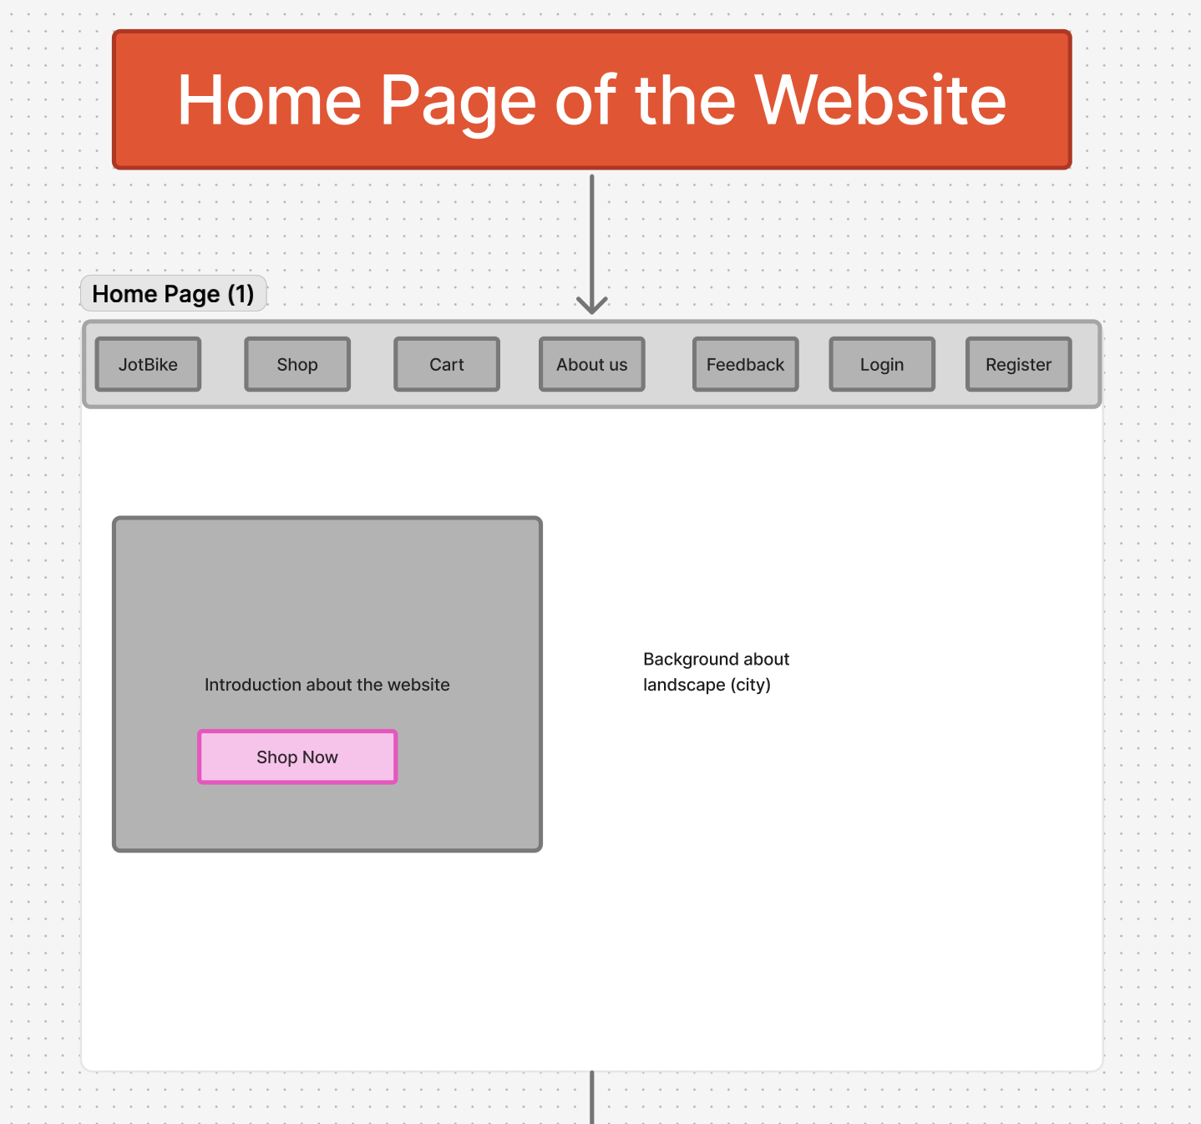

Figure : Home page

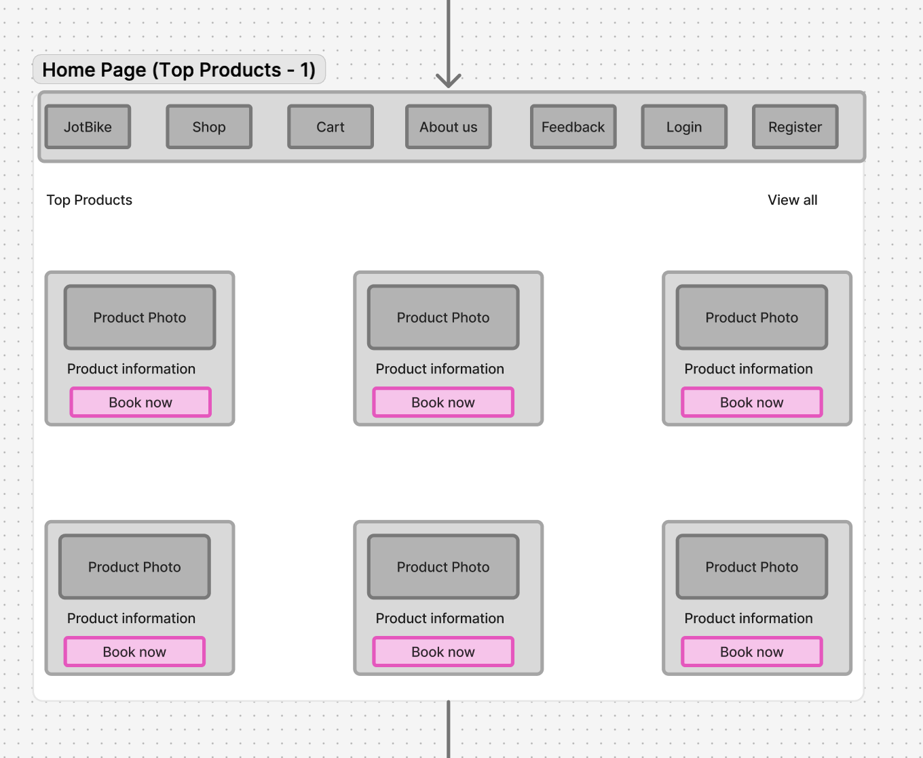

Figure : Home Page product

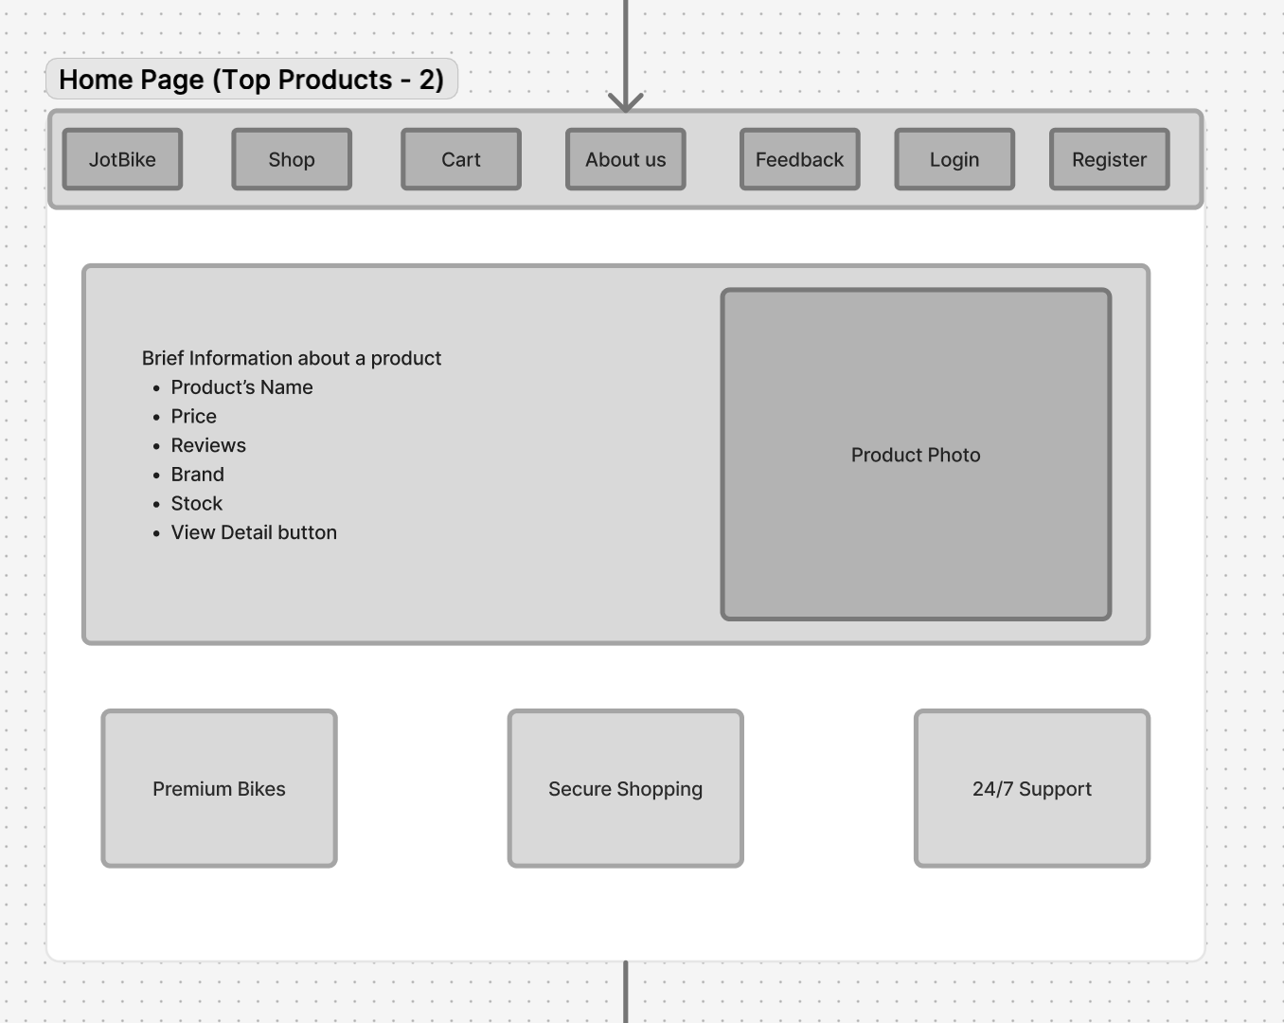

Figure : Home Page Product 2

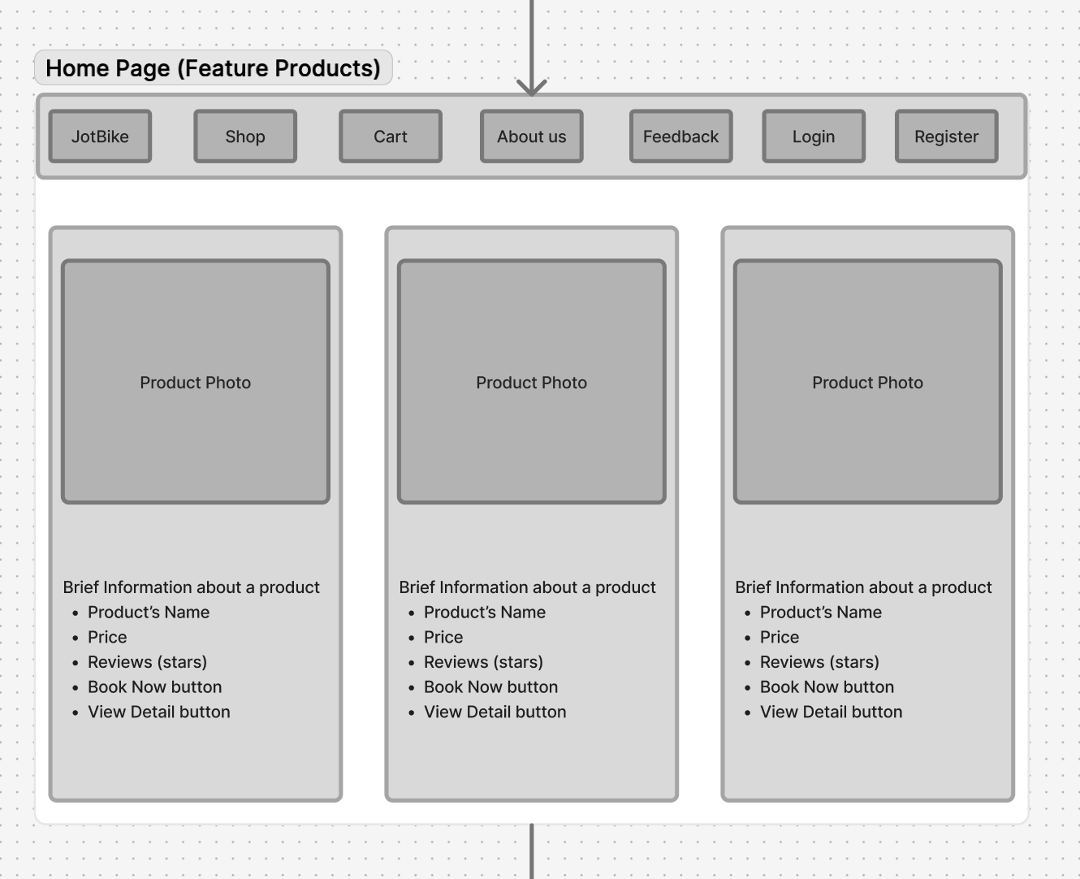

Figure : Home Page Feature Product

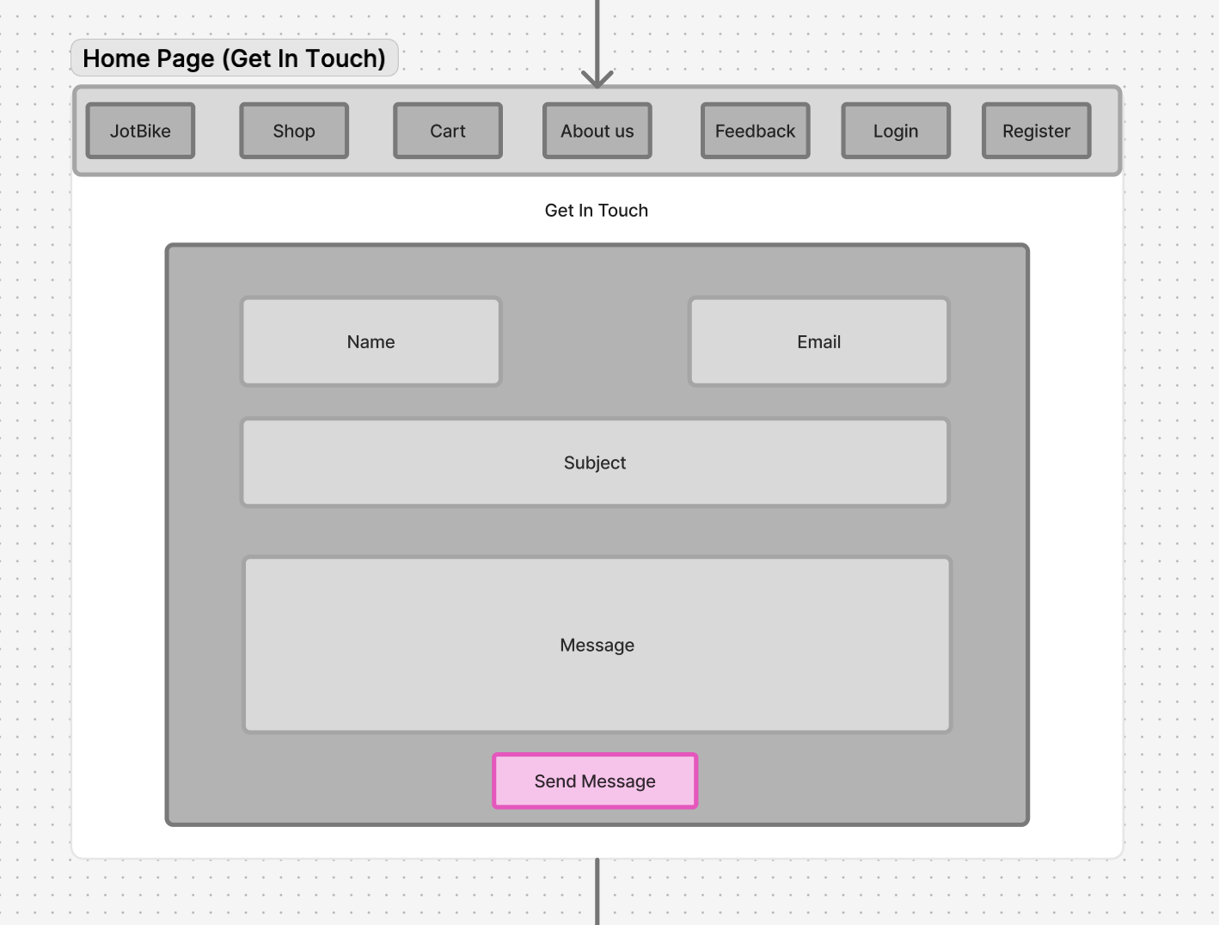

Figure : Home Page Get In Touch

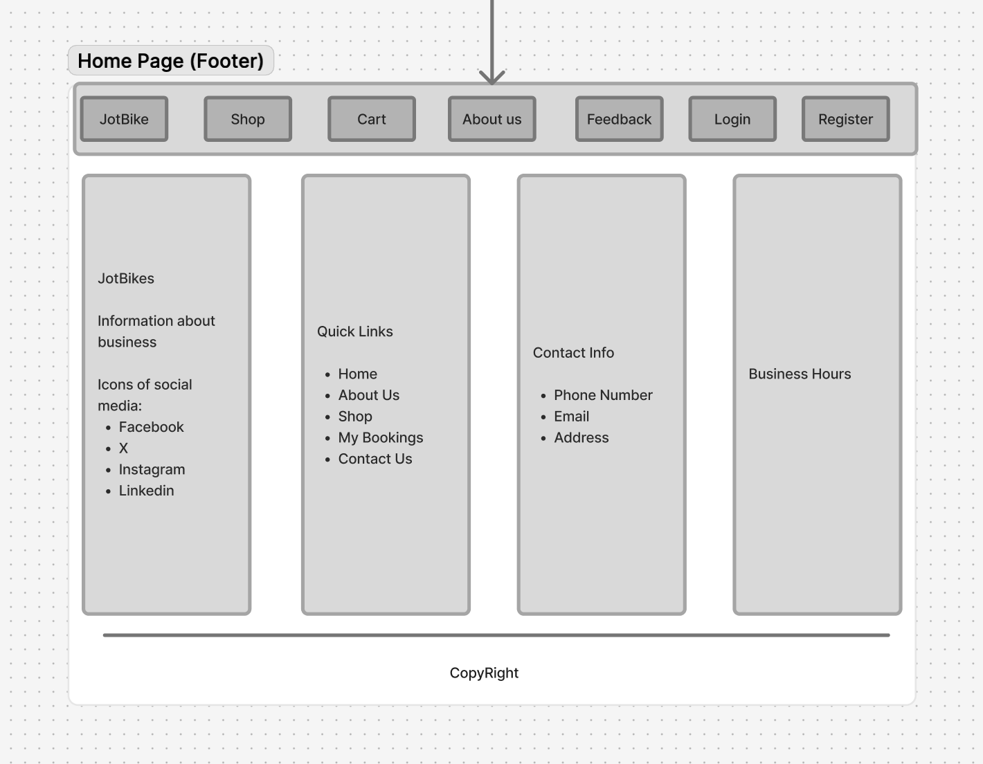

Figure : Home Page Footer

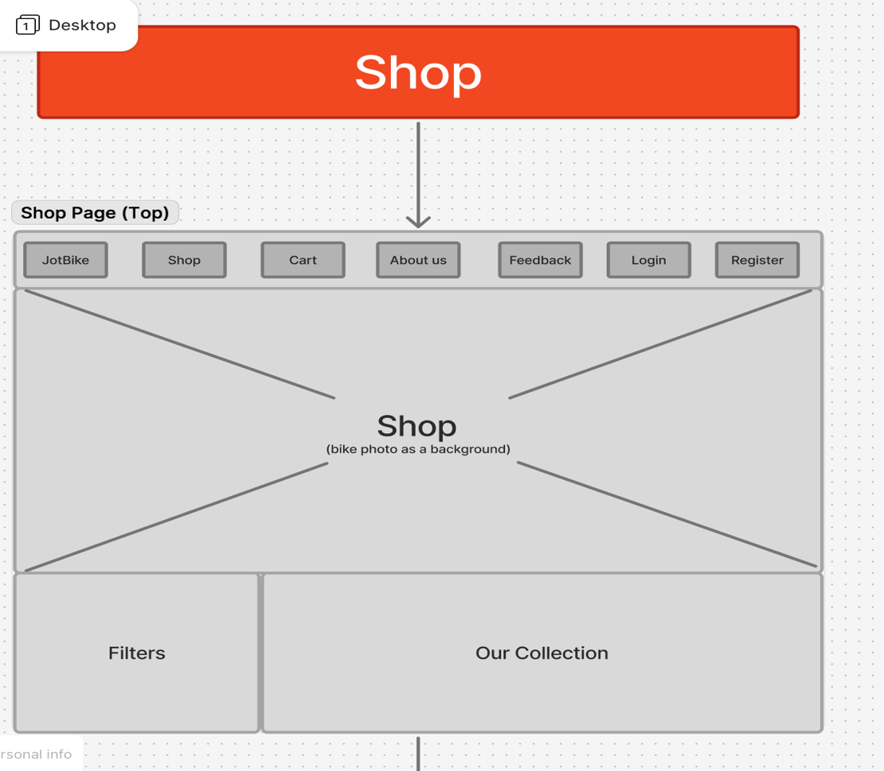

Figure : Shop page

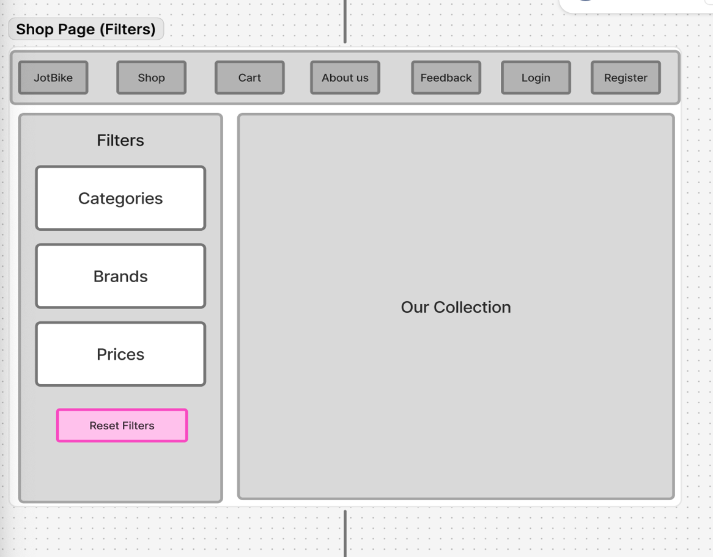

Figure : Shop page filter

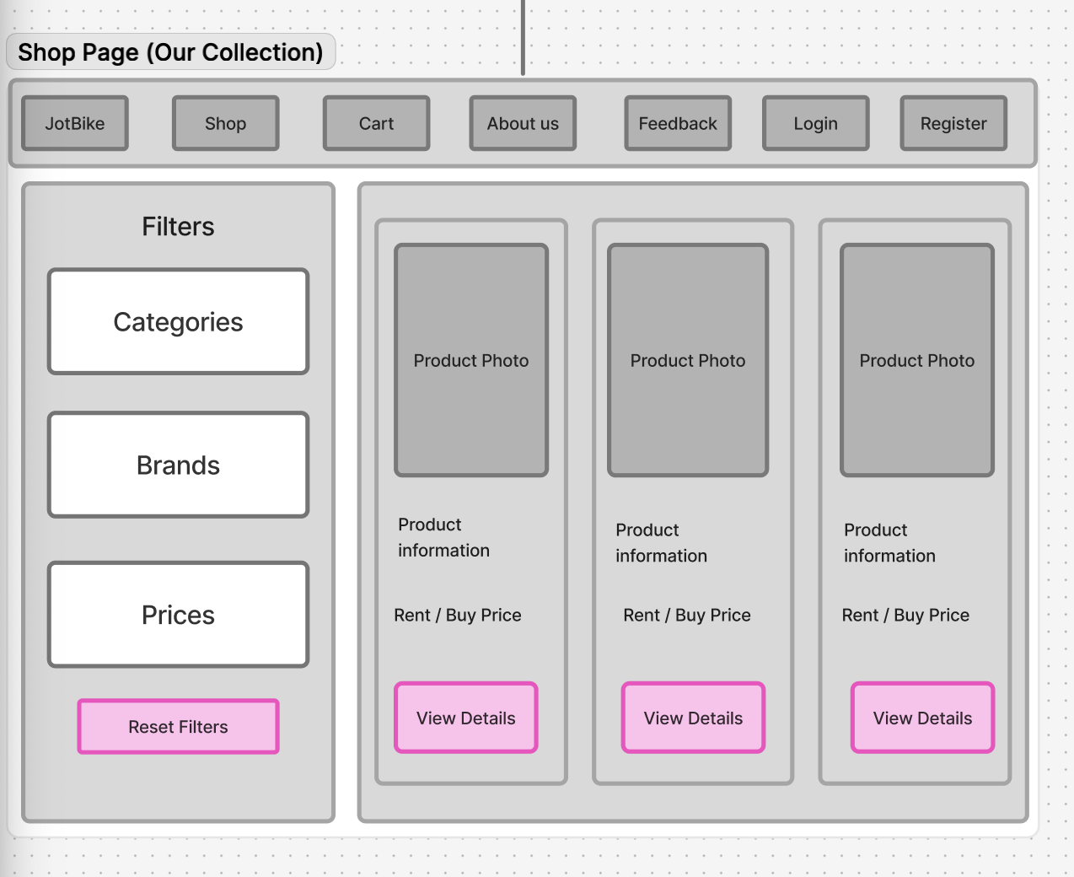

Figure : Shop page Our Collection

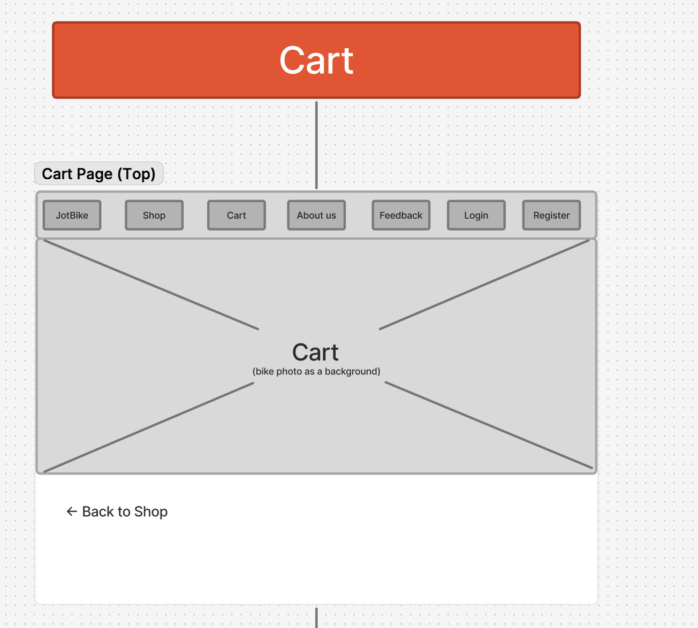

Figure : Cart Page

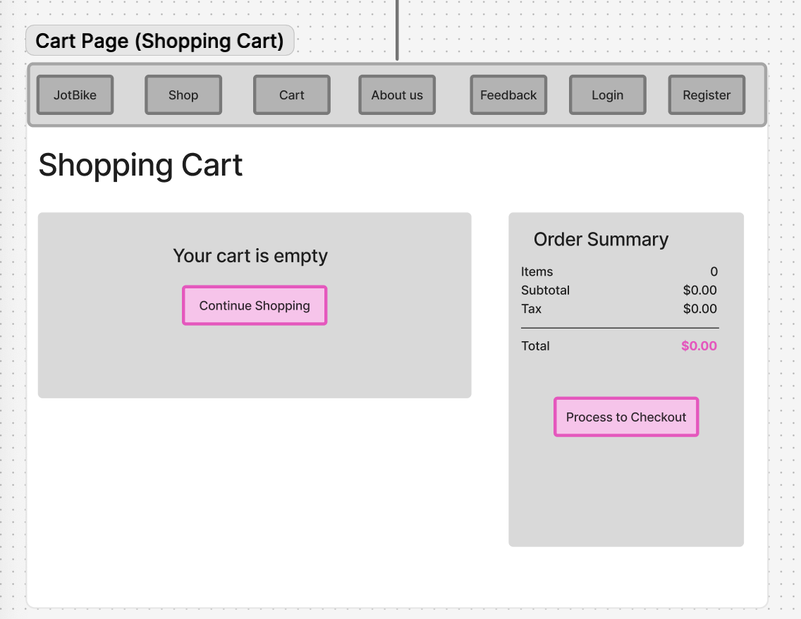

Figure : Cart Page (Shopping Cart)

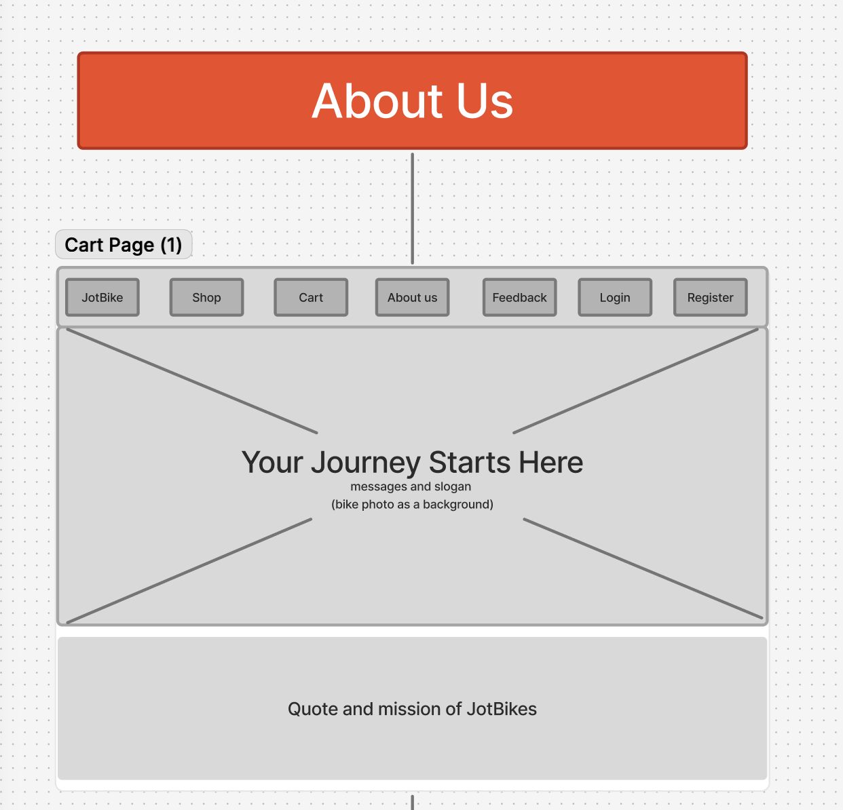

Figure : About Us

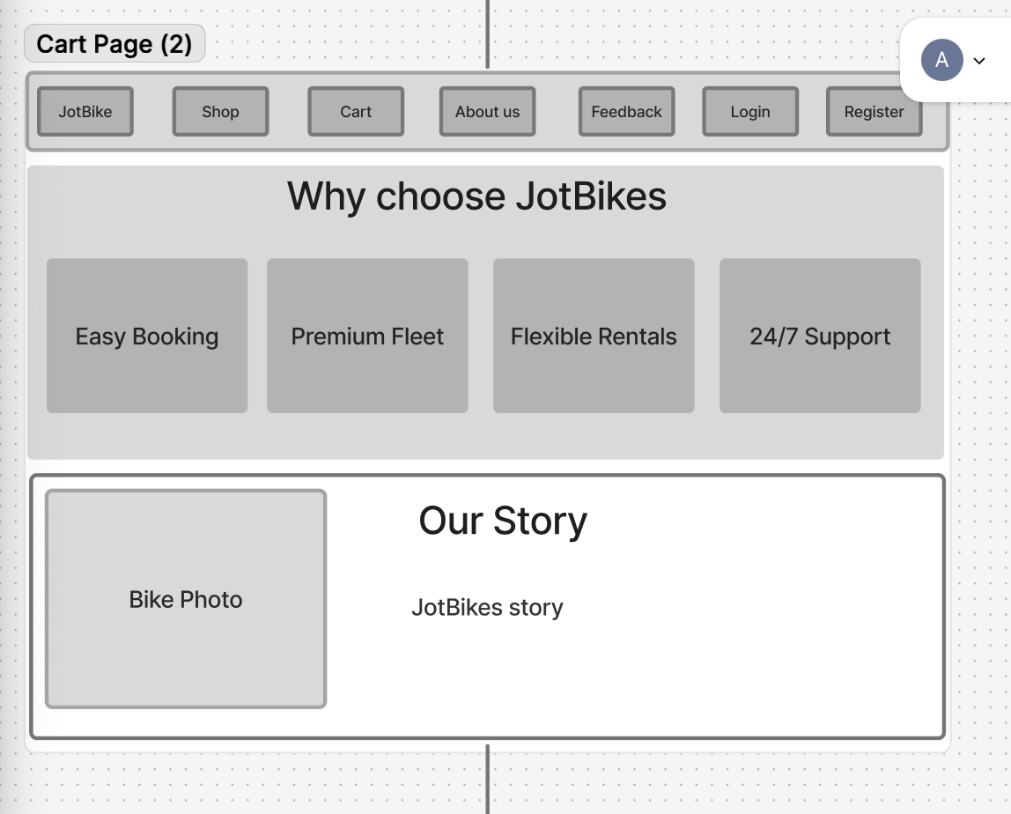

Figure : About Us part 2

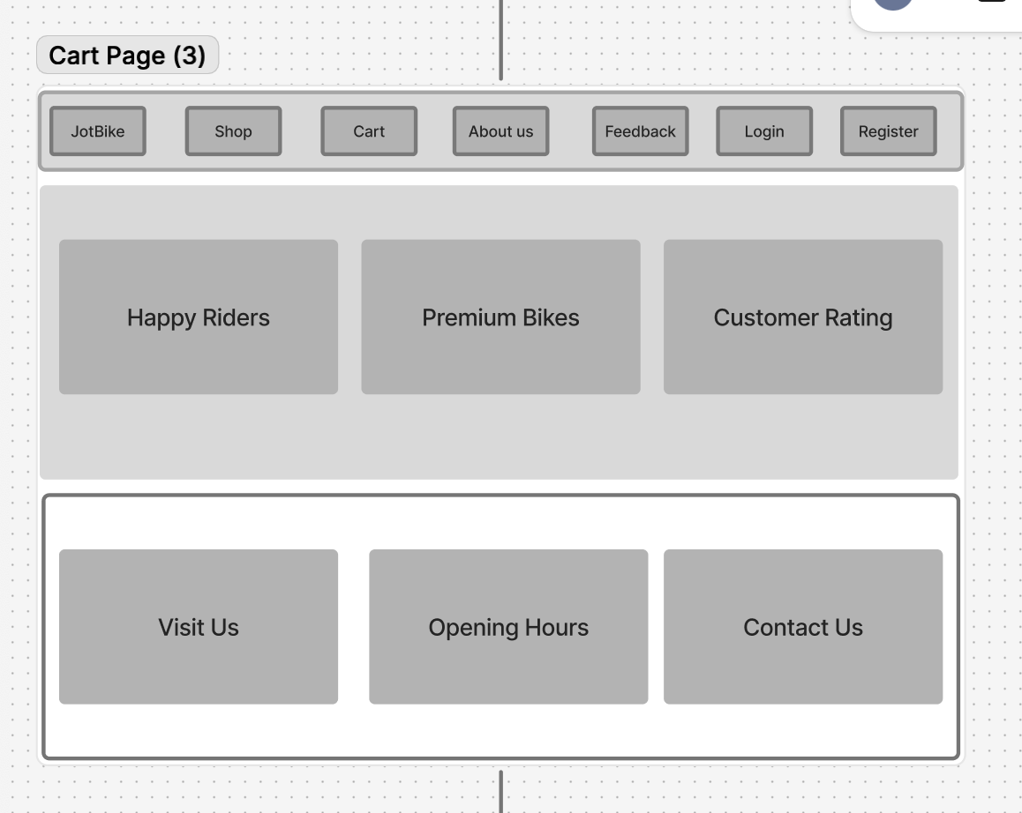

Figure : About Us Part 3

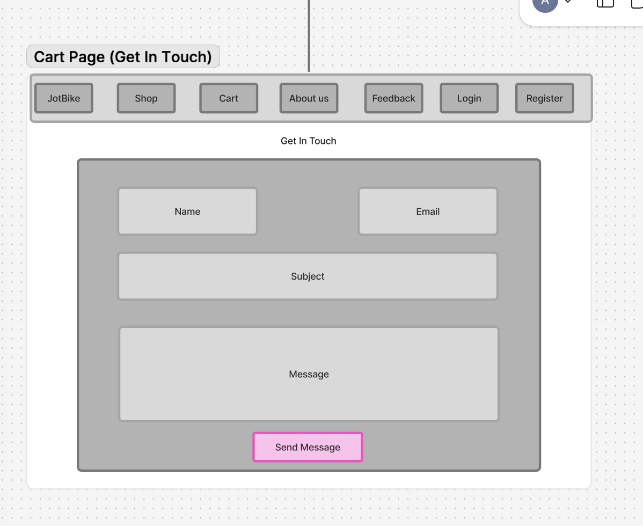

Figure : Get in Touch

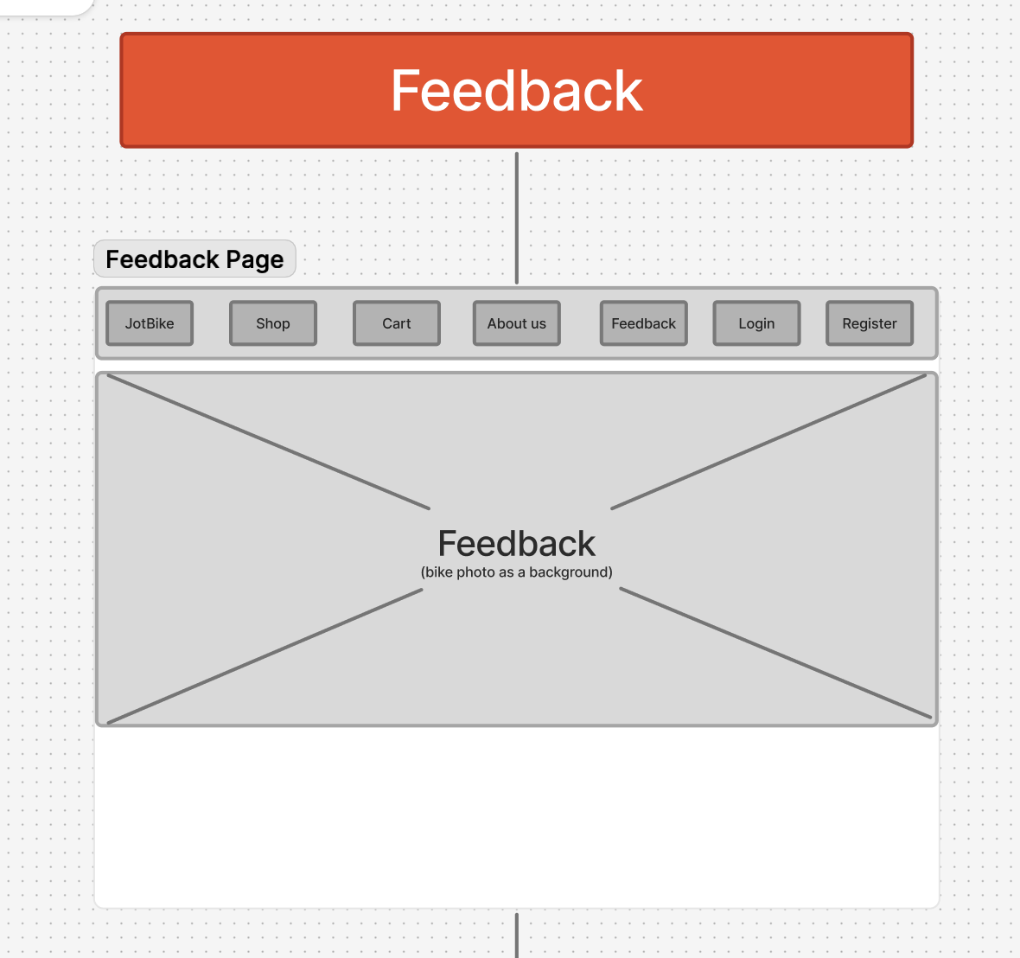

Figure : Feedback

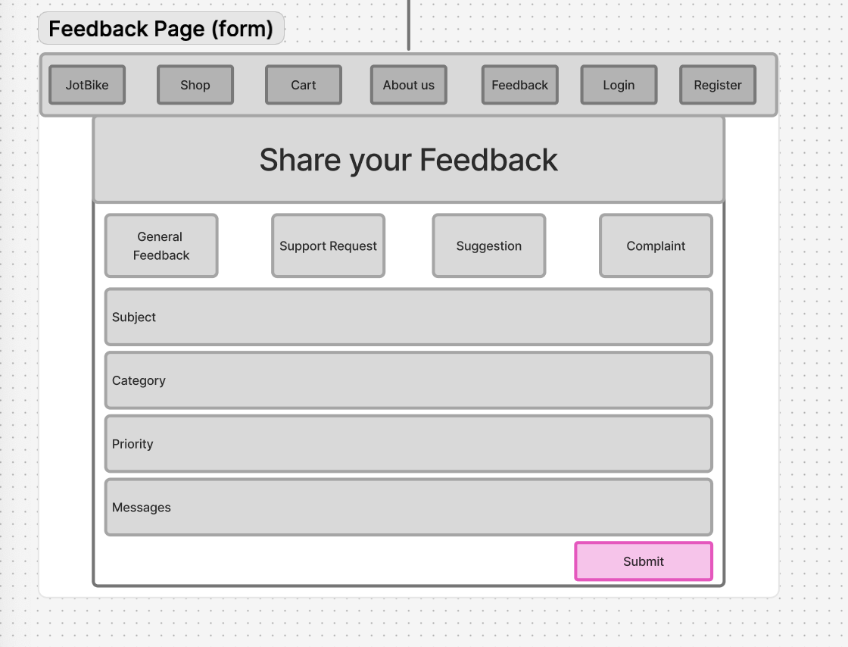

Figure : Feedback Form

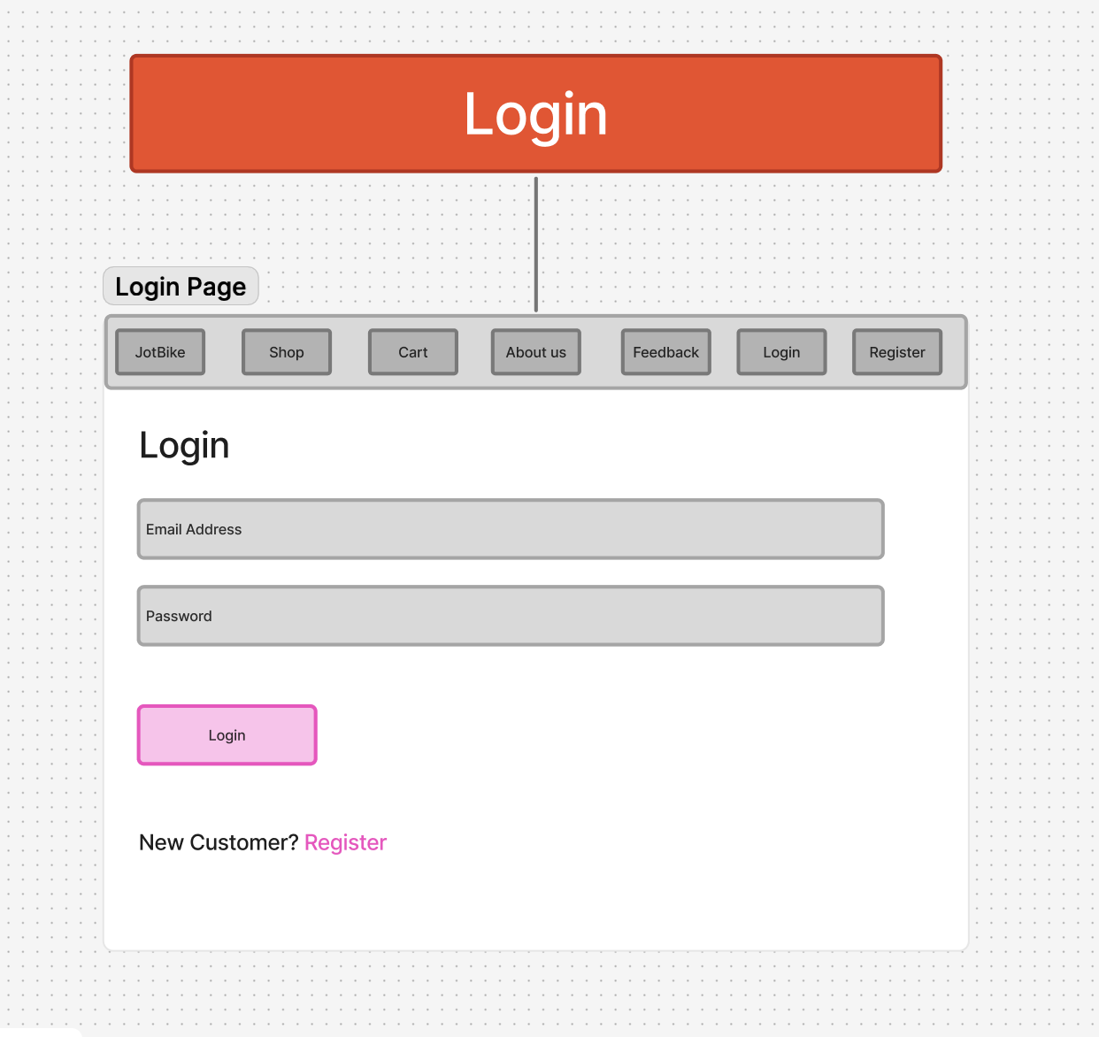

Figure : Login Page

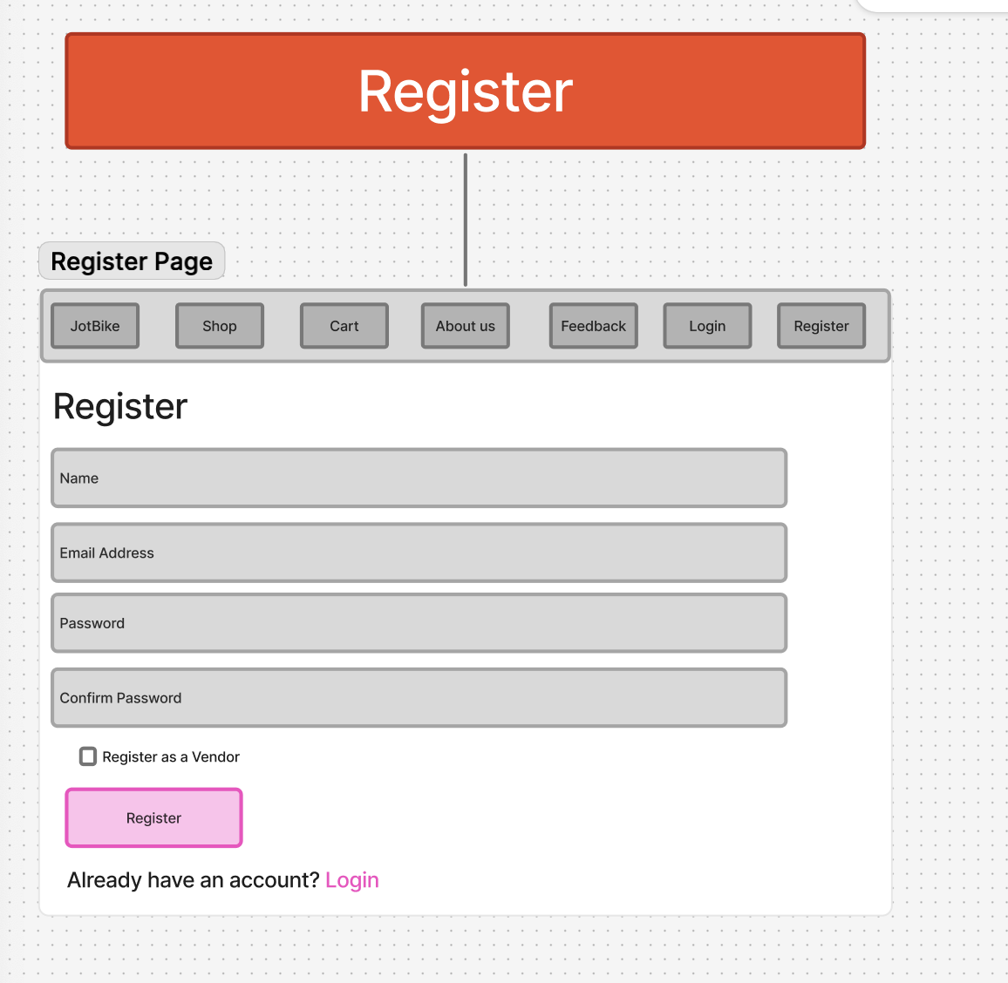

Figure : Register Page

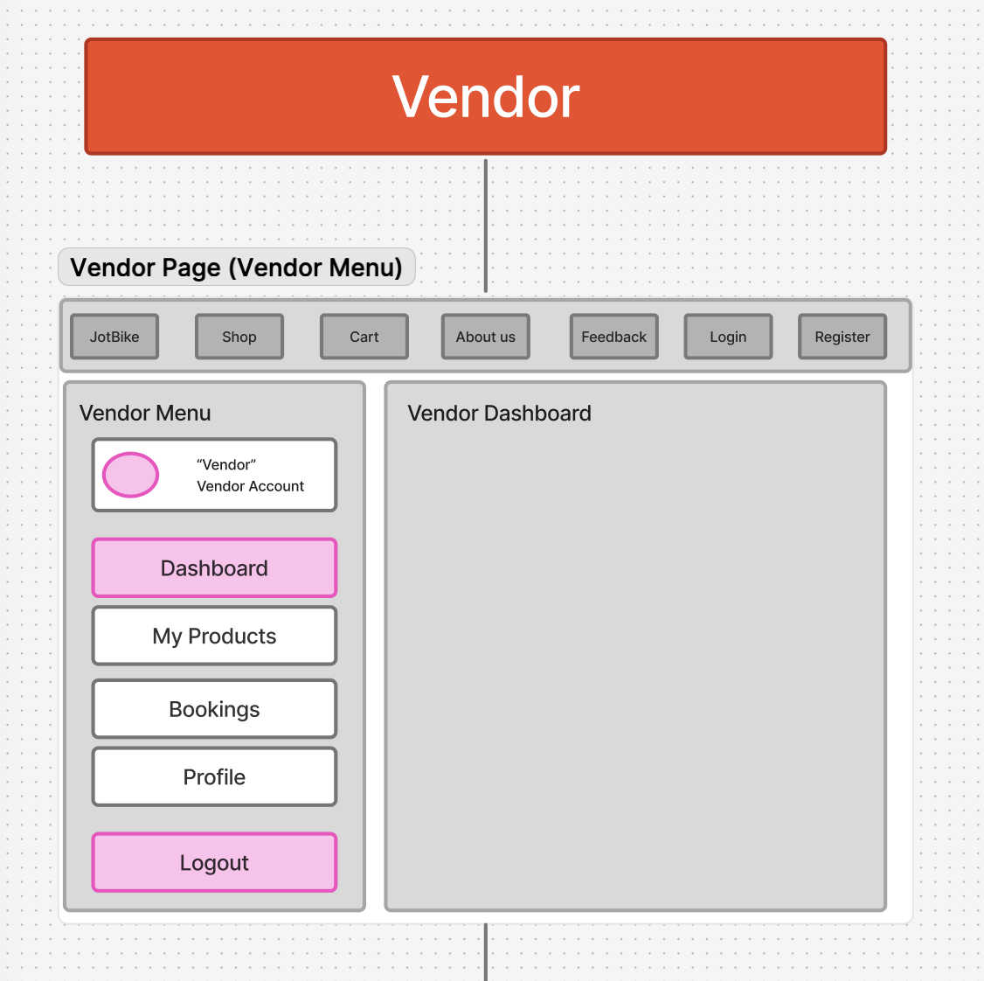

Figure : Vendor Page

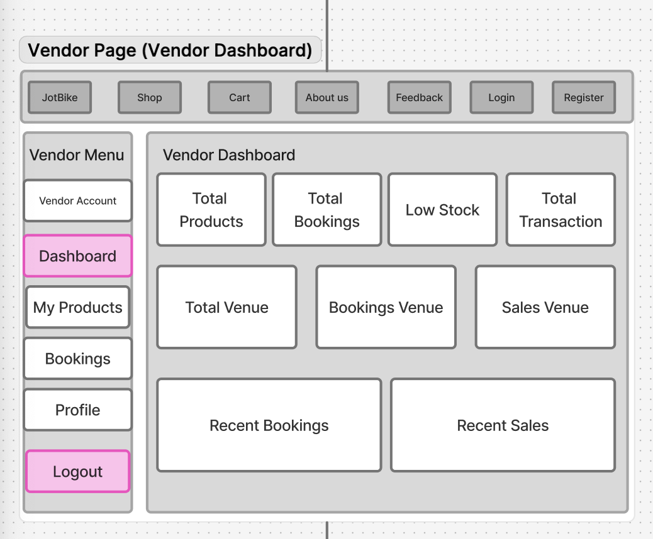

Figure : Vendor Dashboard

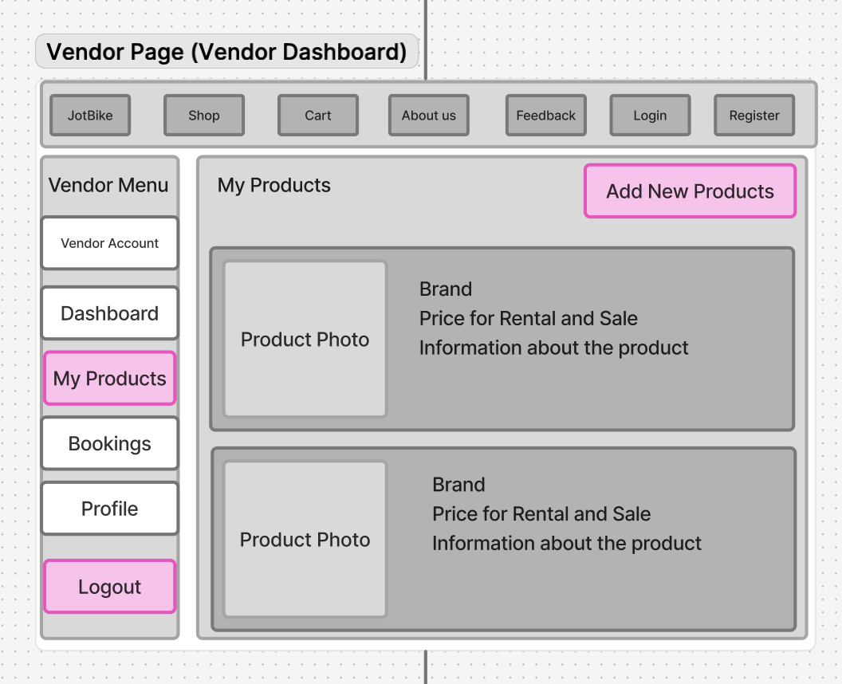

Figure : Vendor Add Product

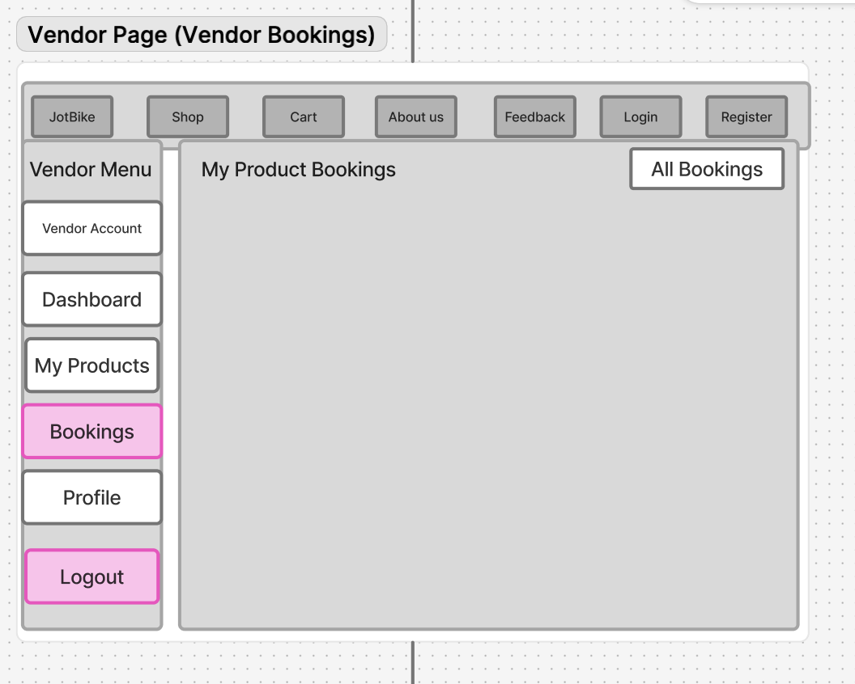

Figure : Vendor Bookings

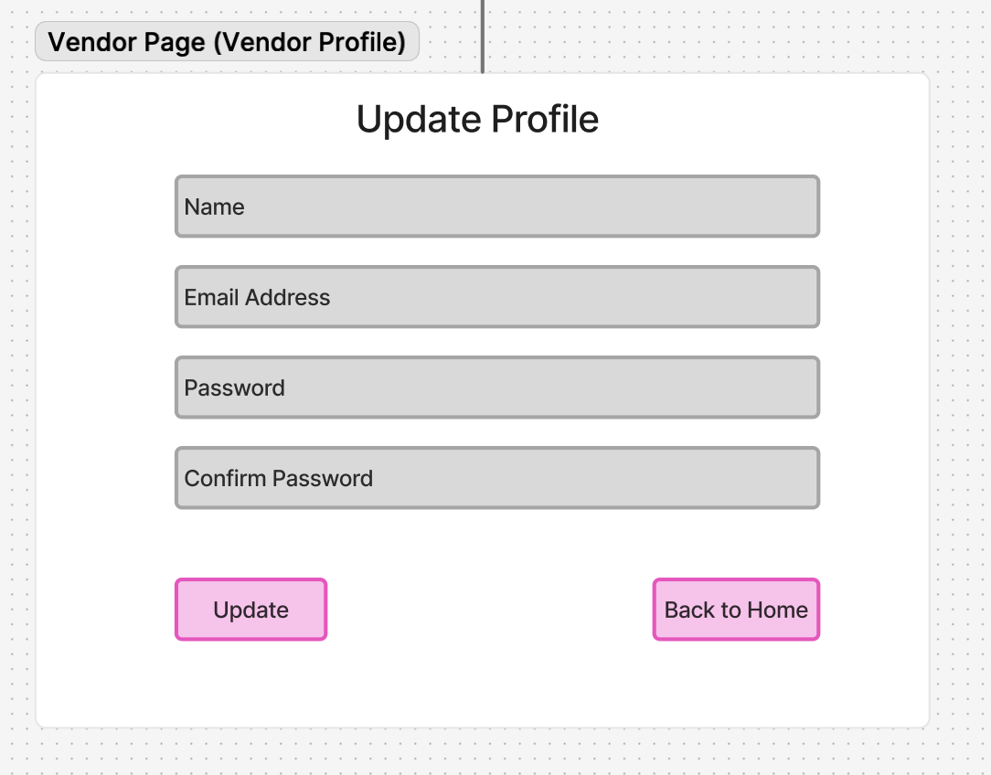

Figure : Vendor Profile

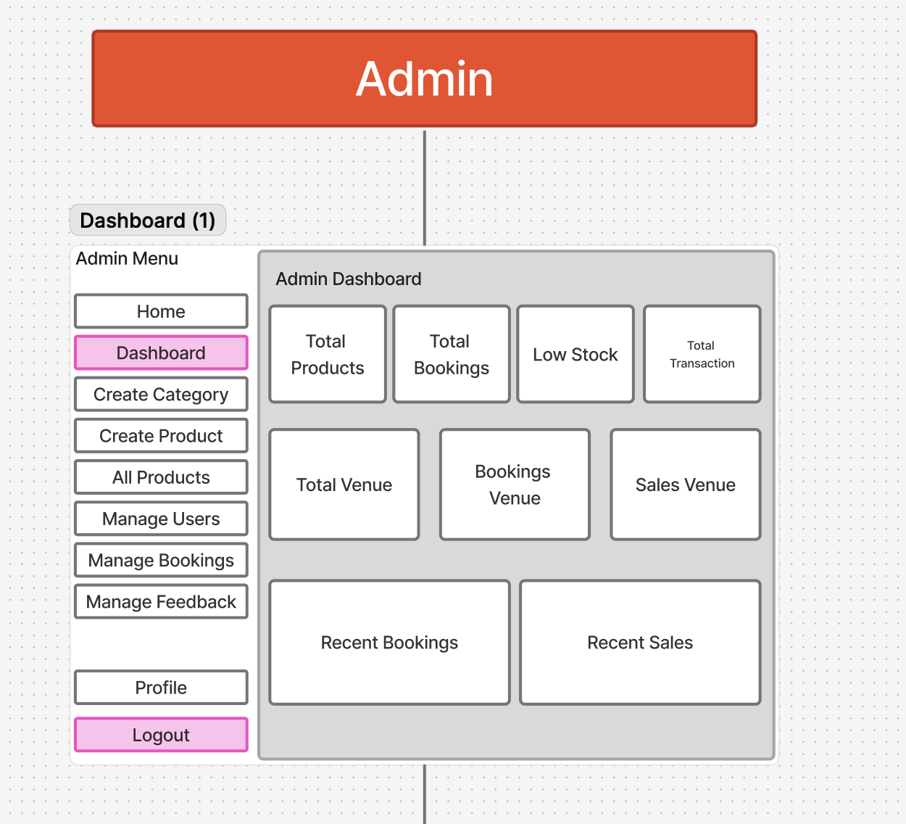

Figure : Admin Dashboard

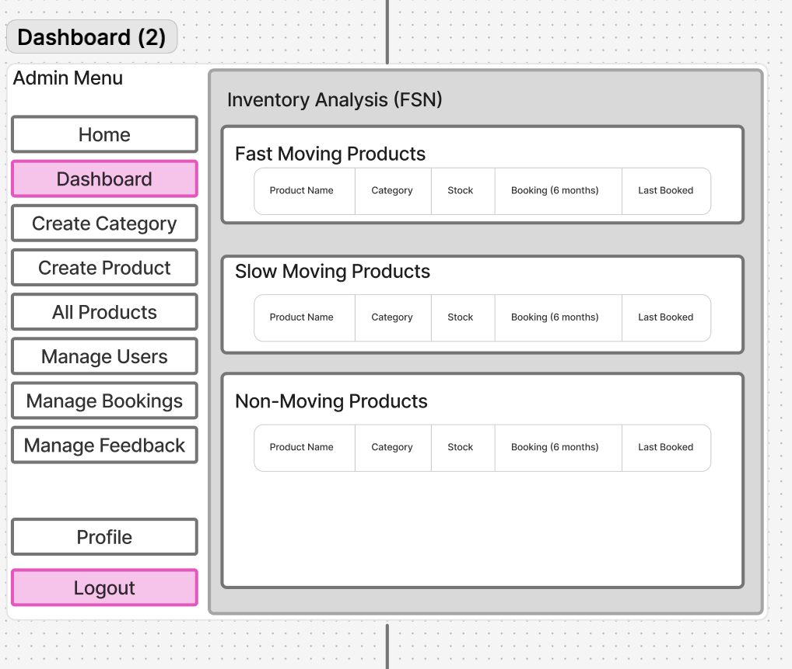

Figure : Admin Dashboard Part 2

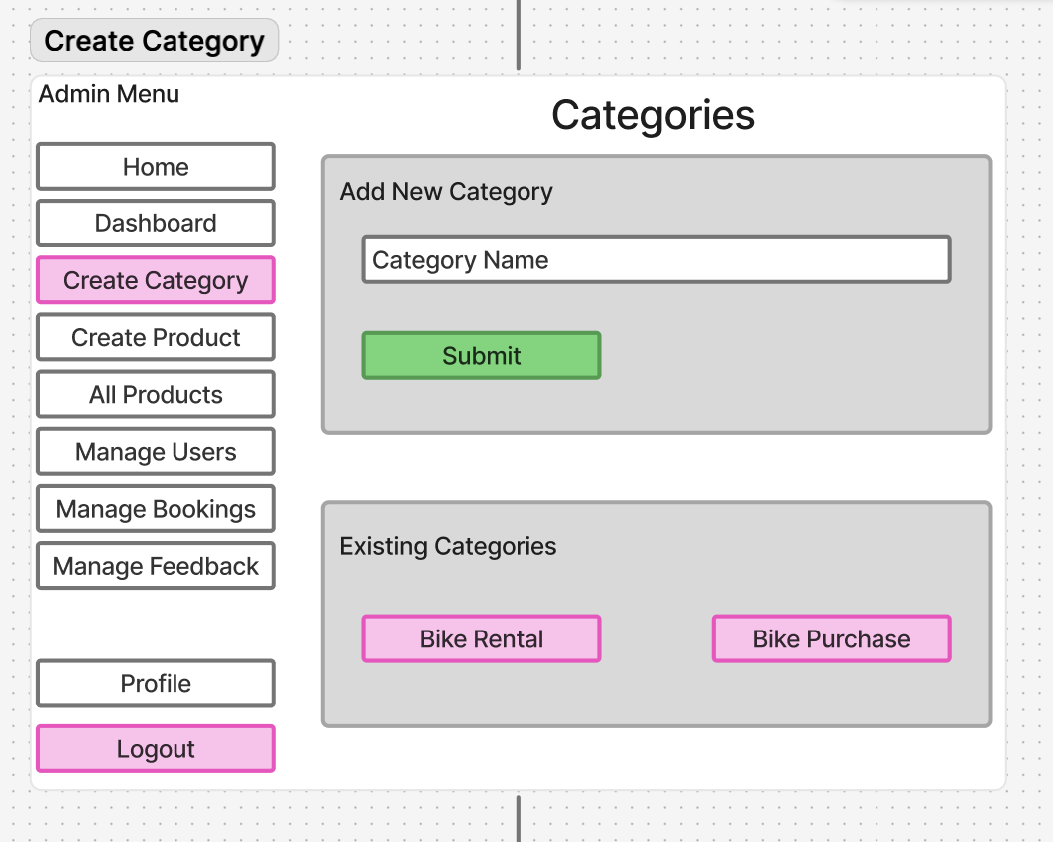

Figure : Admin Create Category

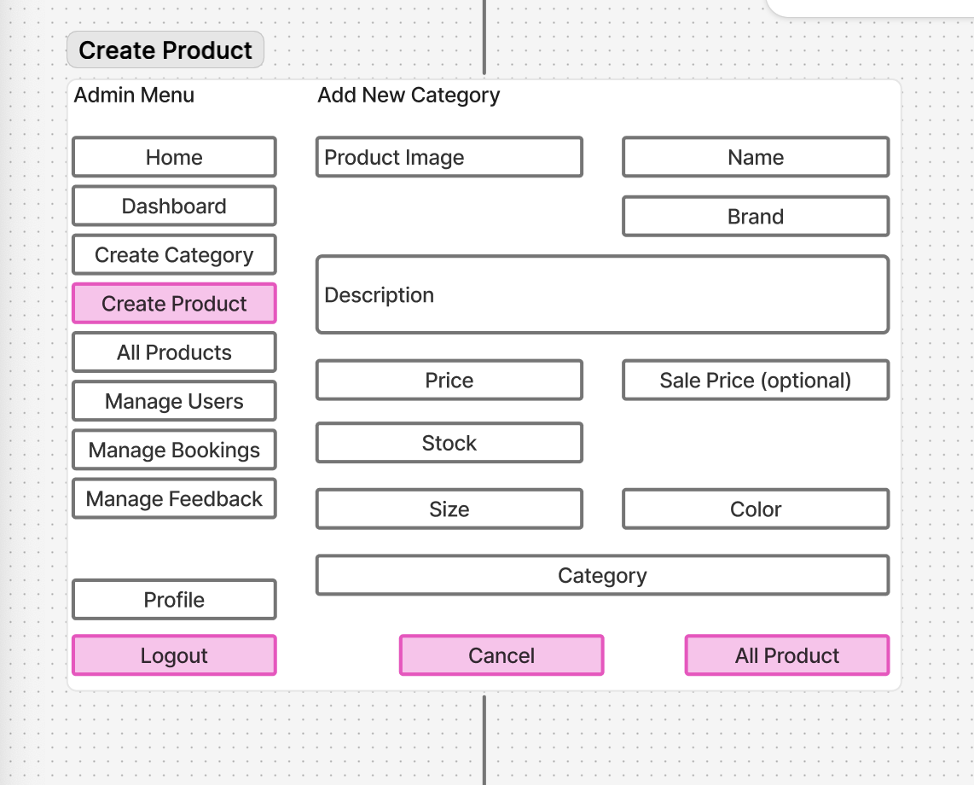

Figure : Admin Create Product

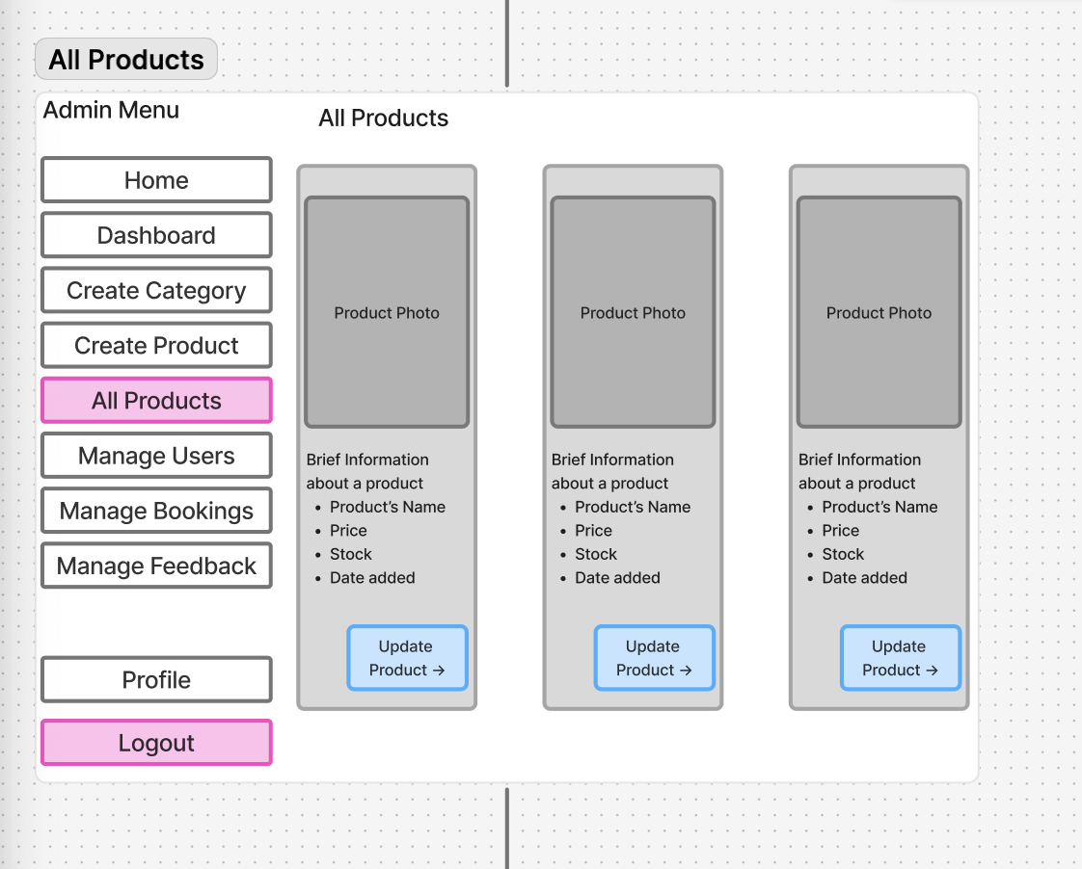

Figure : Admin All Product

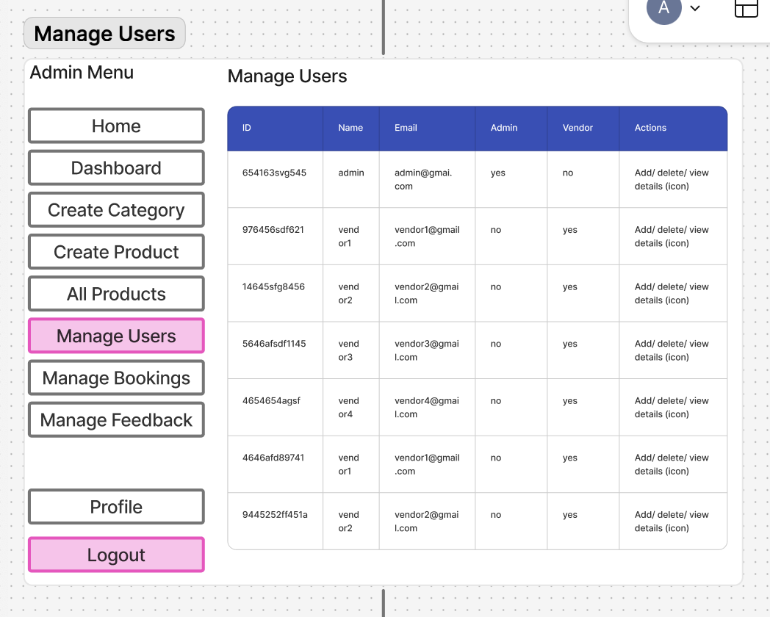

Figure : Admin Manage User

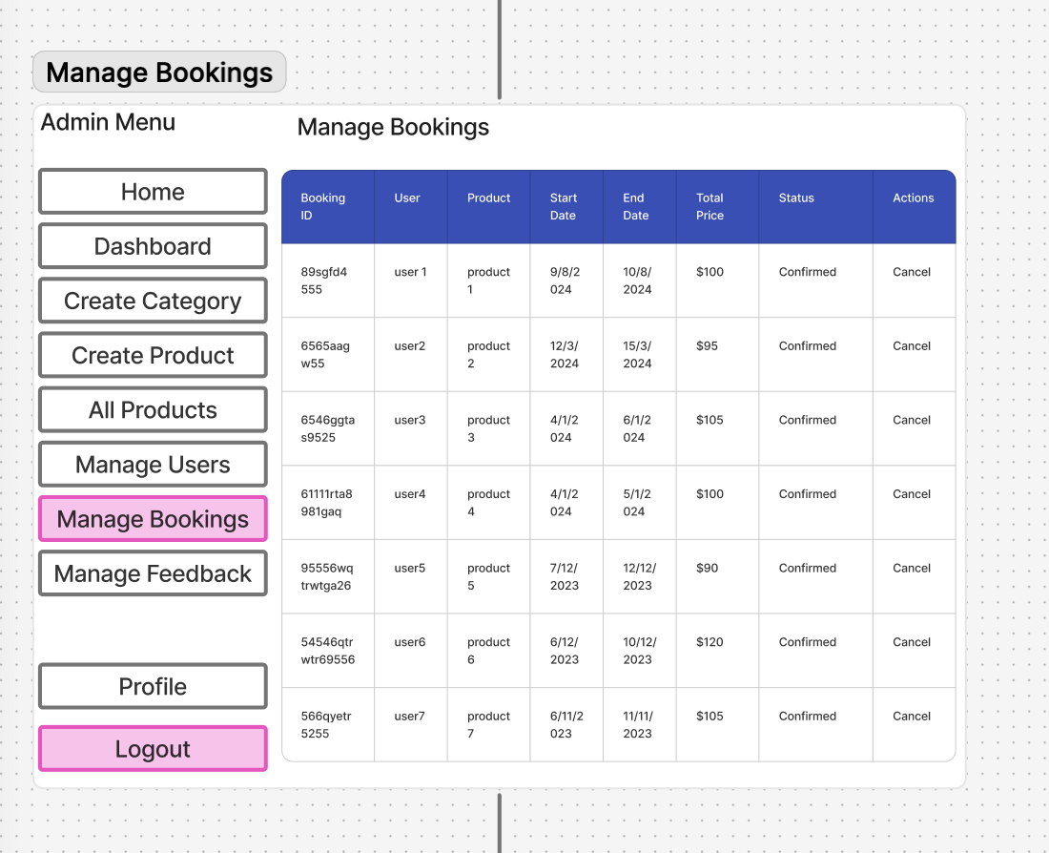

Figure : Admin Manage Booking

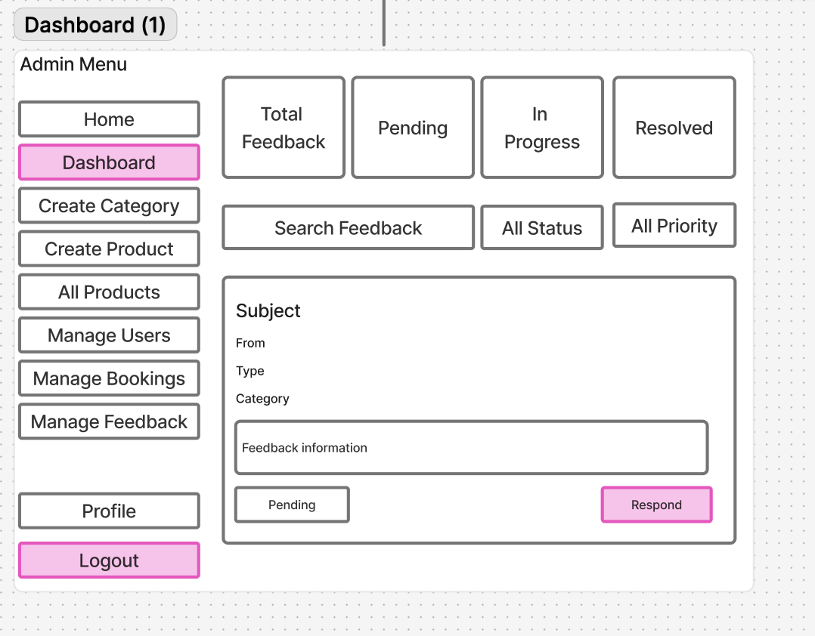

Figure : Admin Feedback Page

UI Website Design

Figure : Home Page UI

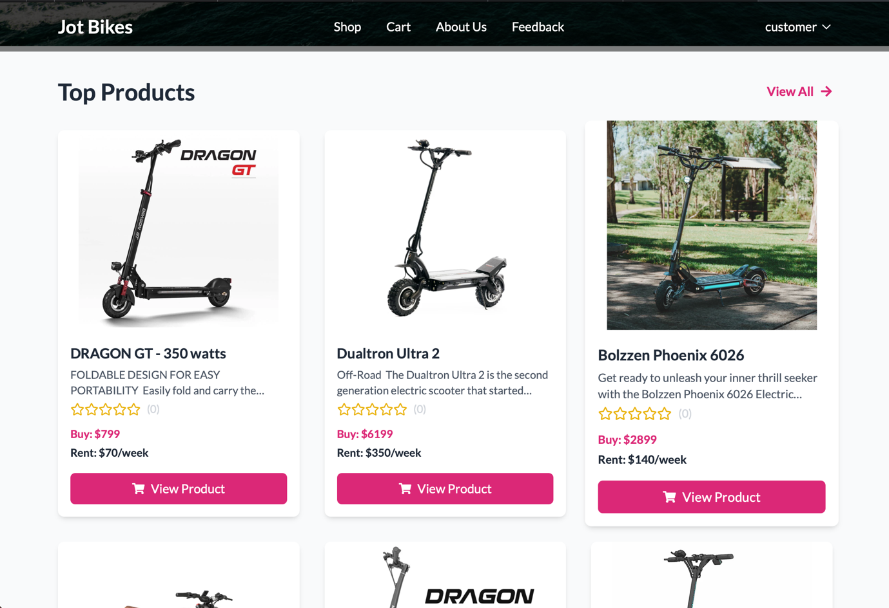

Figure : Home Page Top Product UI

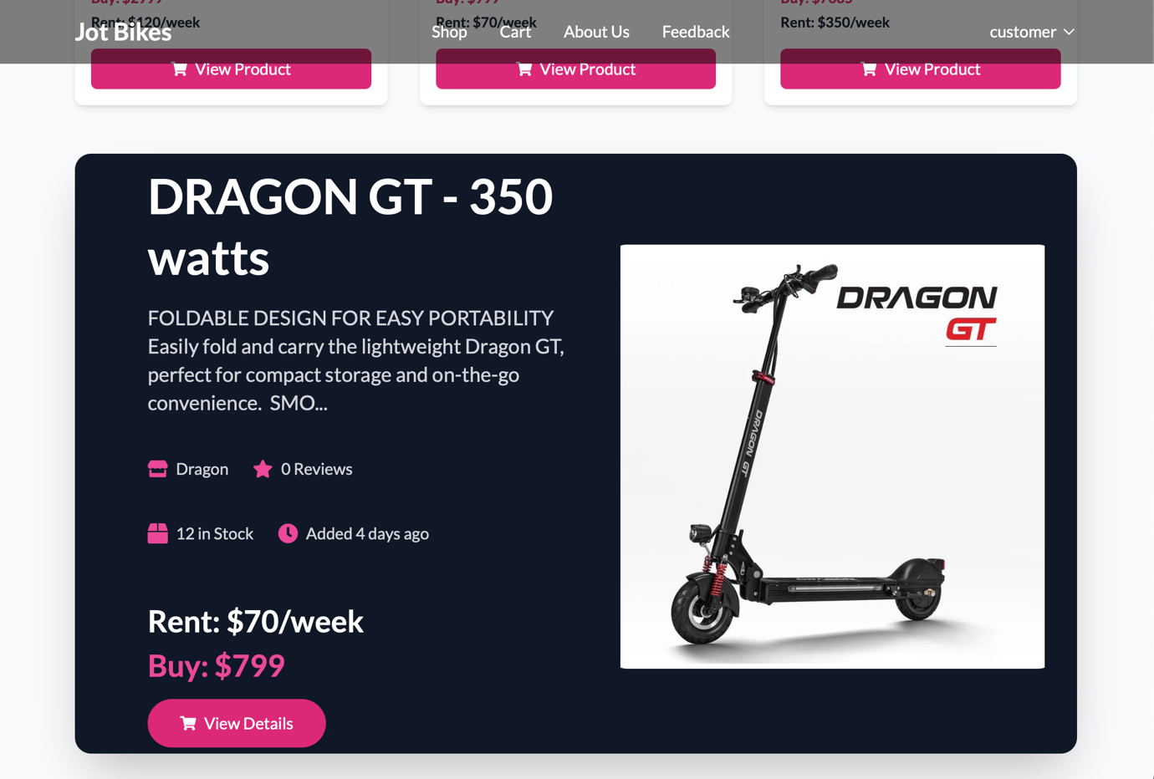

Figure : Home Page Top Product 2 UI

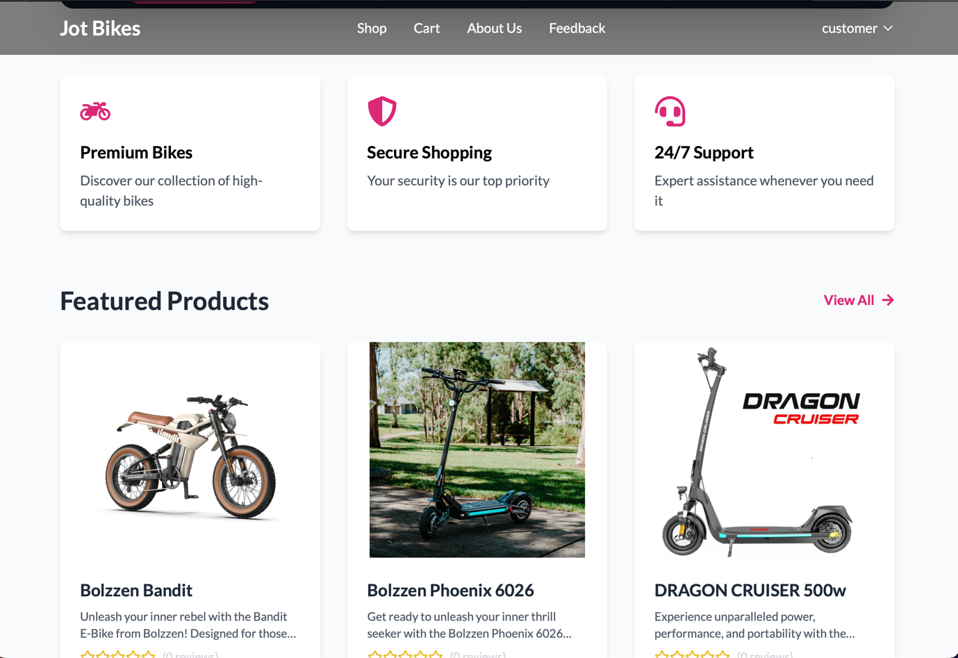

Figure : Home Page Featured Product UI

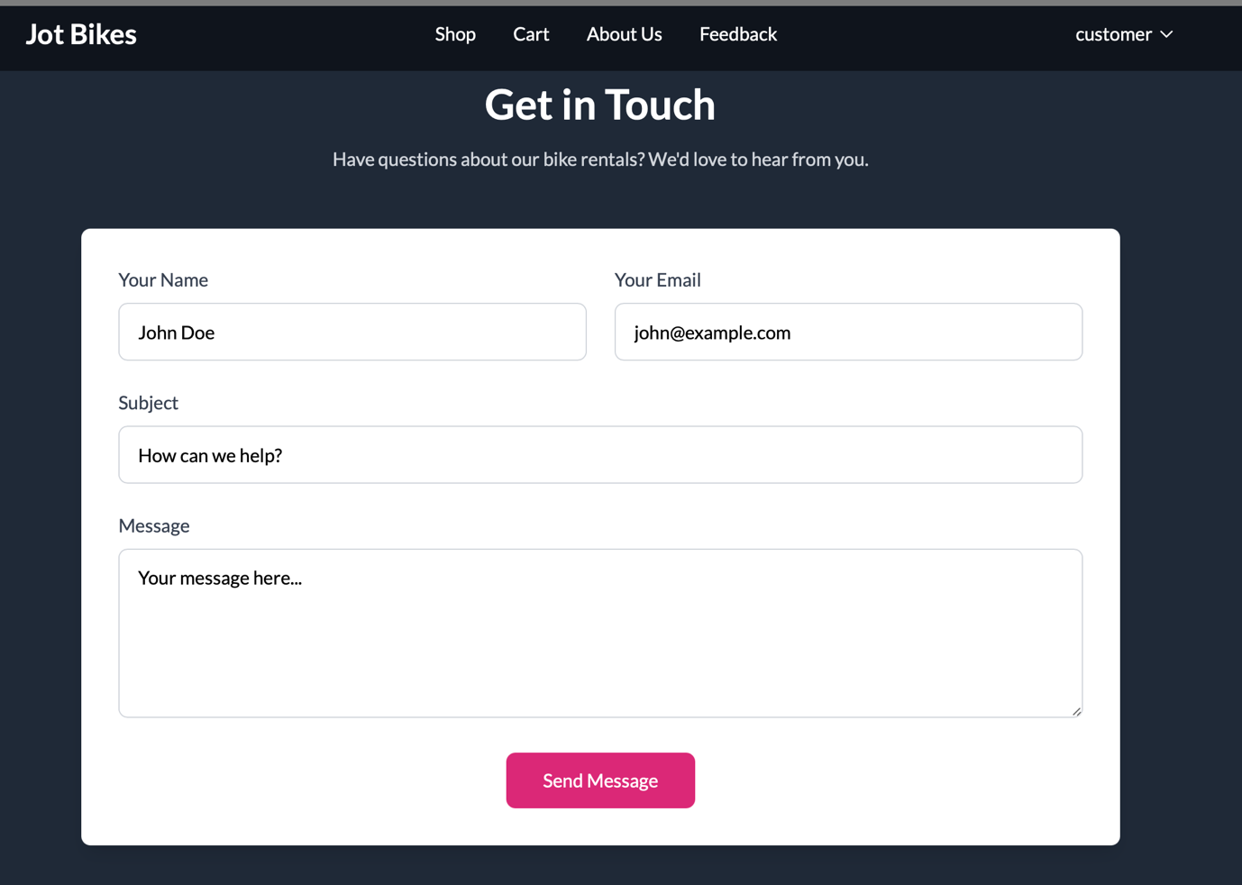

Figure : Home Page Get In Touch UI

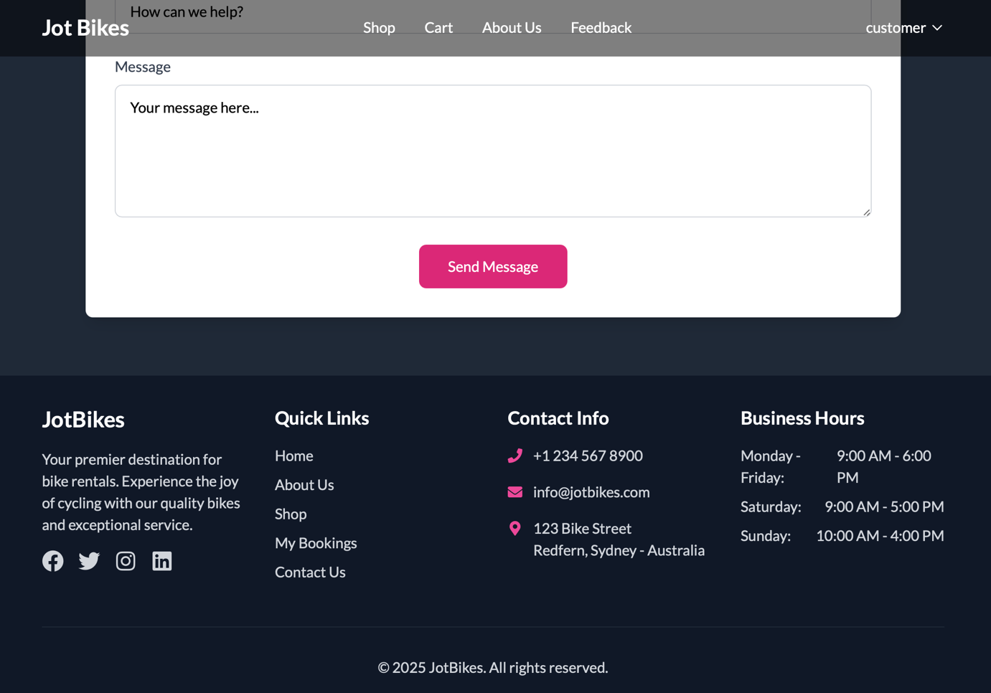

Figure : Home Page Footer UI

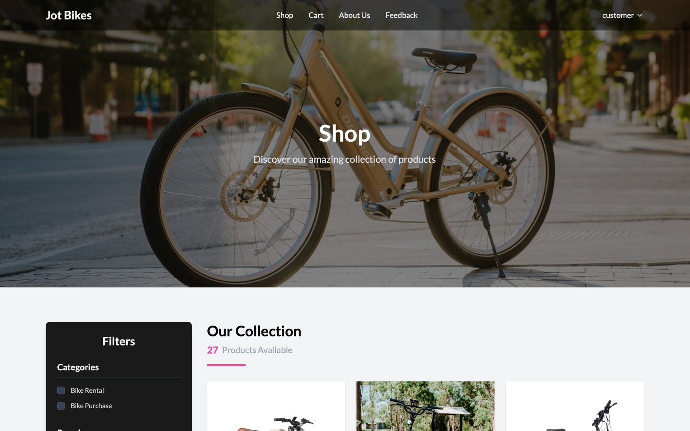

Figure : Shop UI

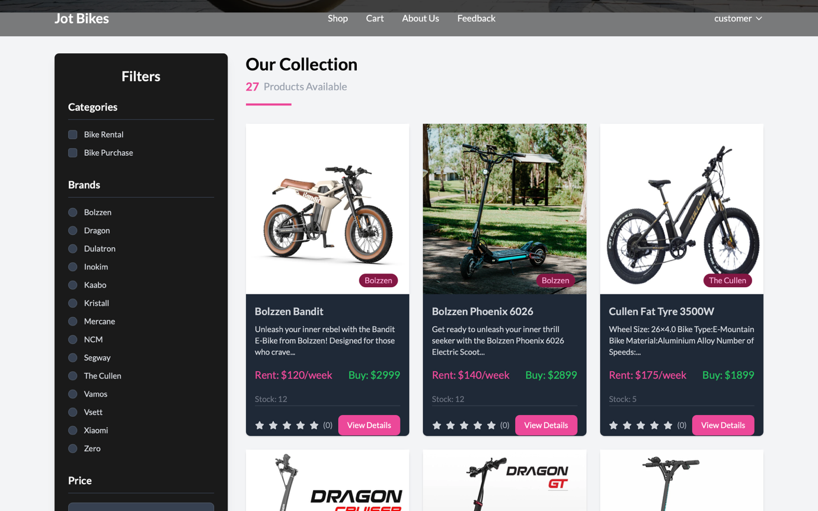

Figure : Shop Our Collection UI

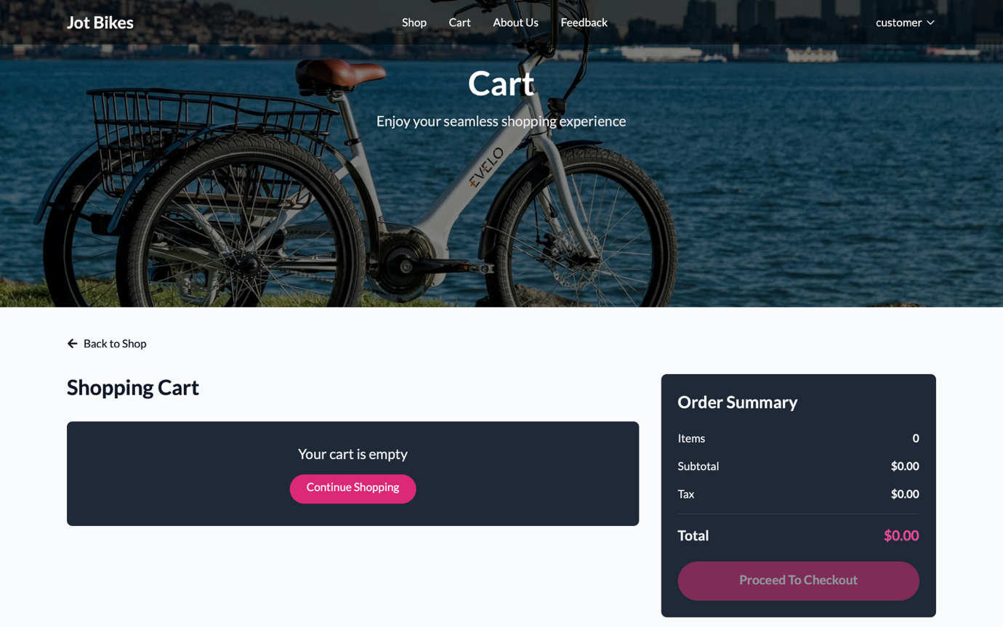

Figure : Cart UI

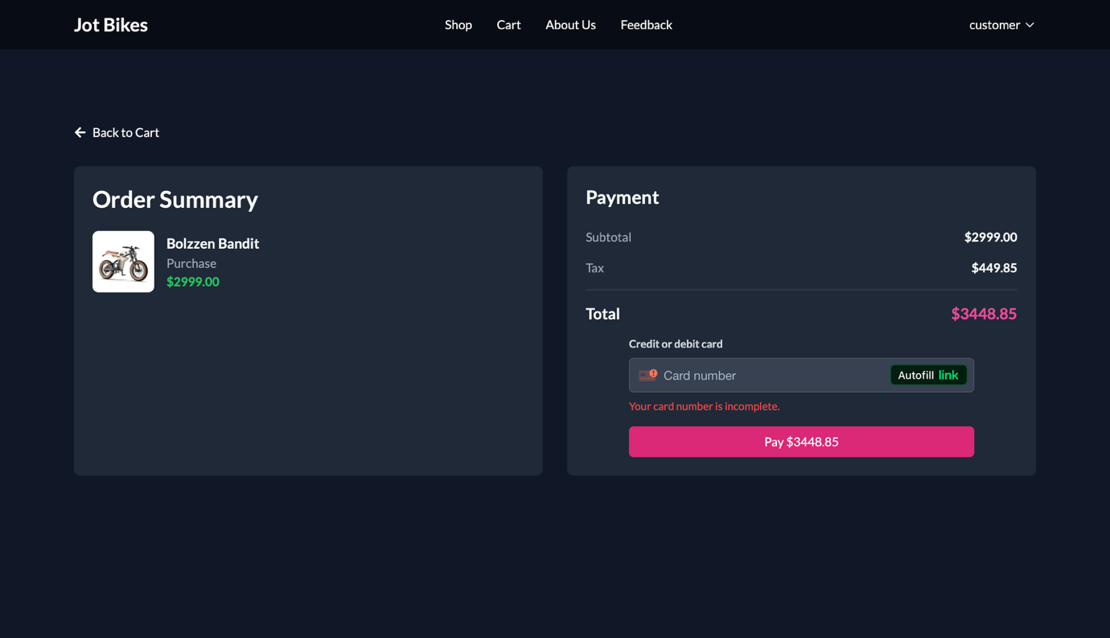

Figure : Payment UI

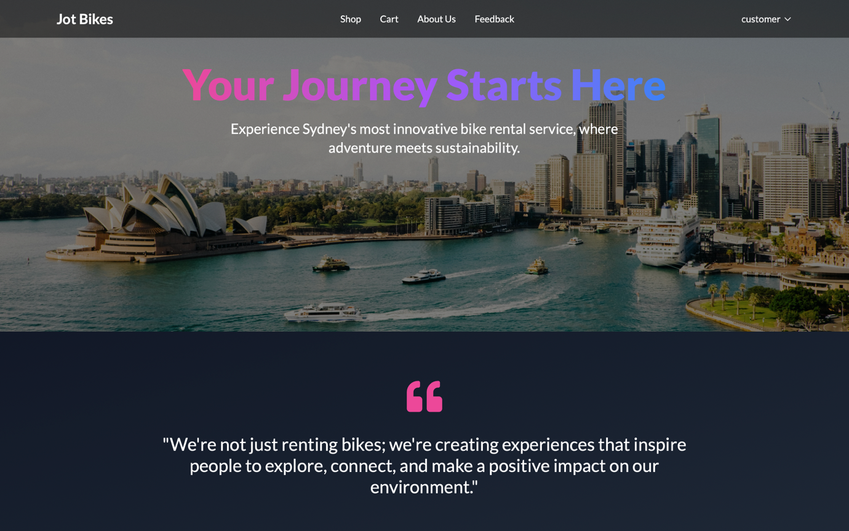

Figure : About Us UI

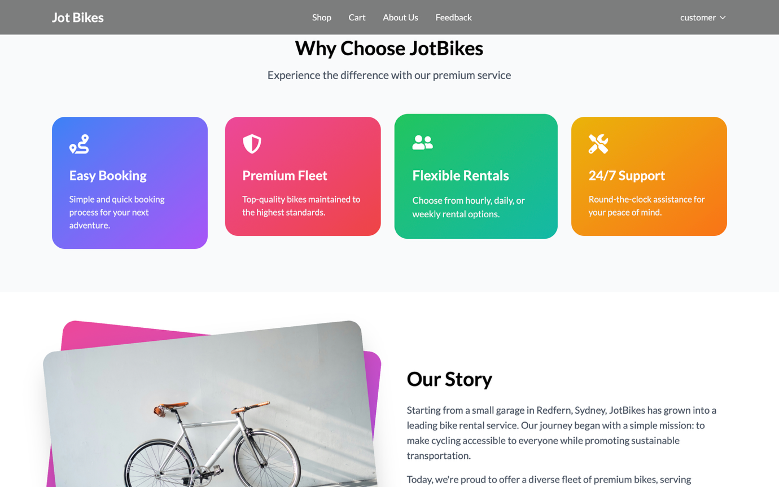

Figure : About Us 2 UI

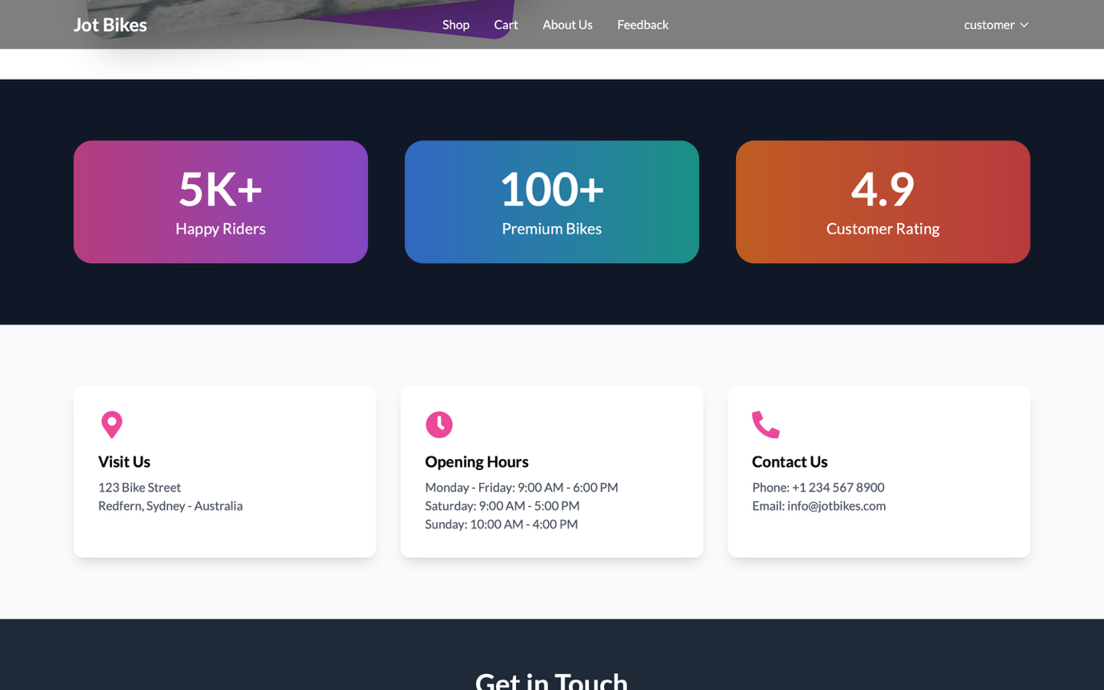

Figure : About Us 3 UI

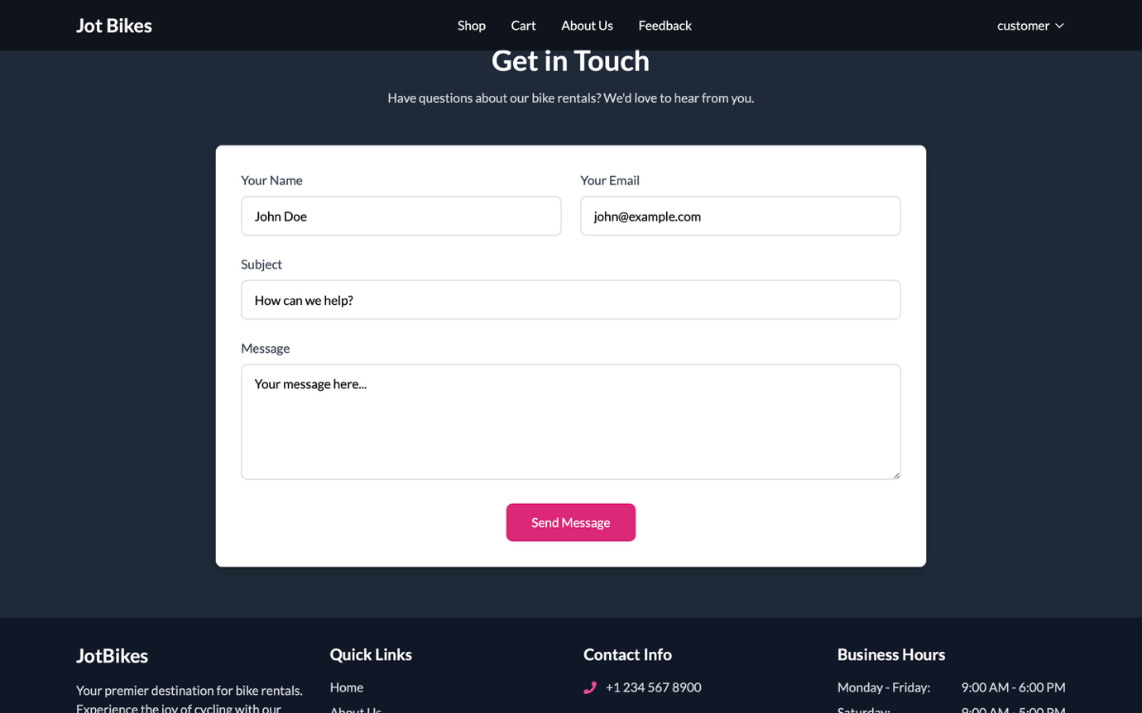

Figure : About Us Footer UI

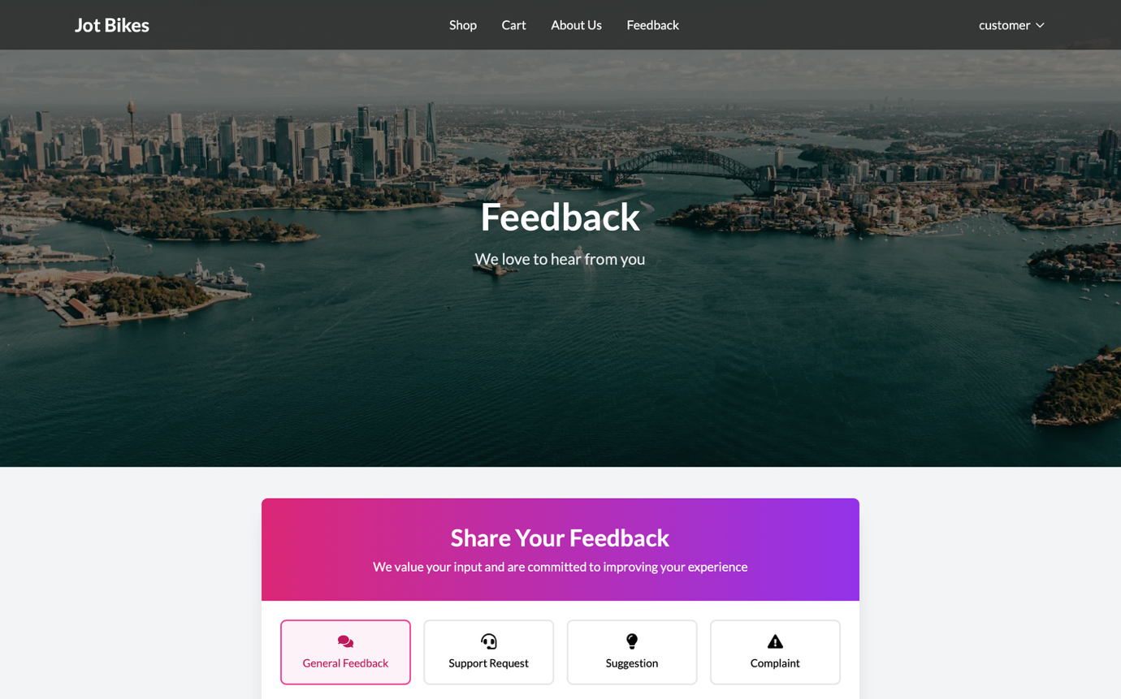

Figure : Feedback UI

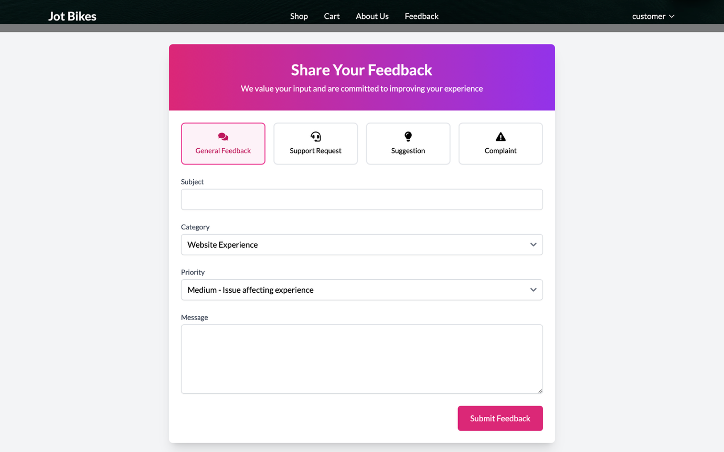

Figure : Feedback Form UI

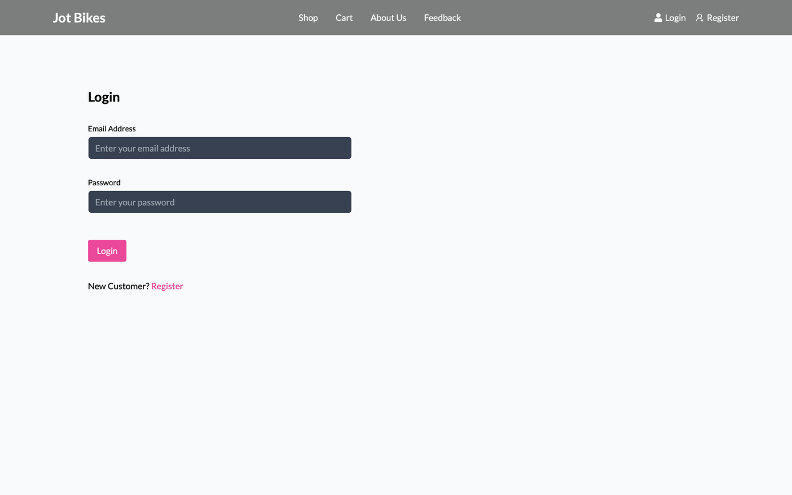

Figure : Login Page UI

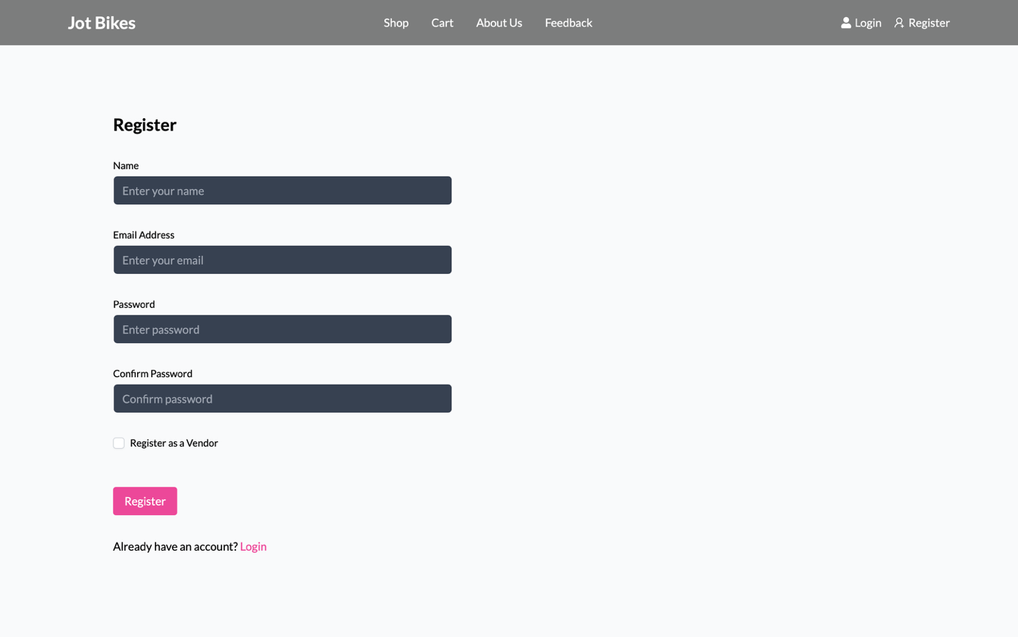

Figure : Register UI

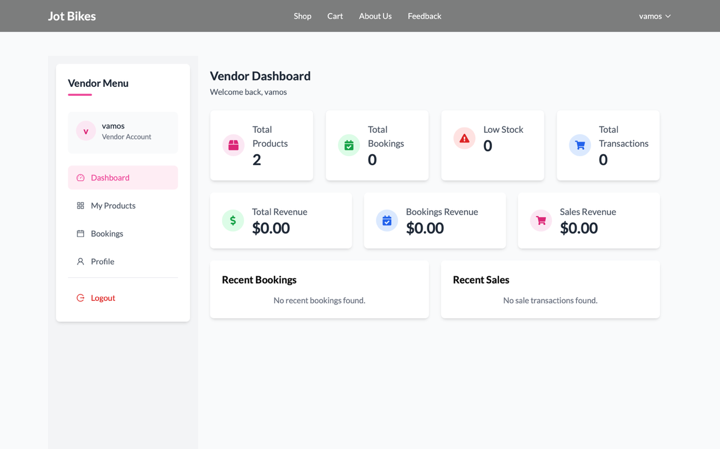

Figure : Vendor Dashboard UI

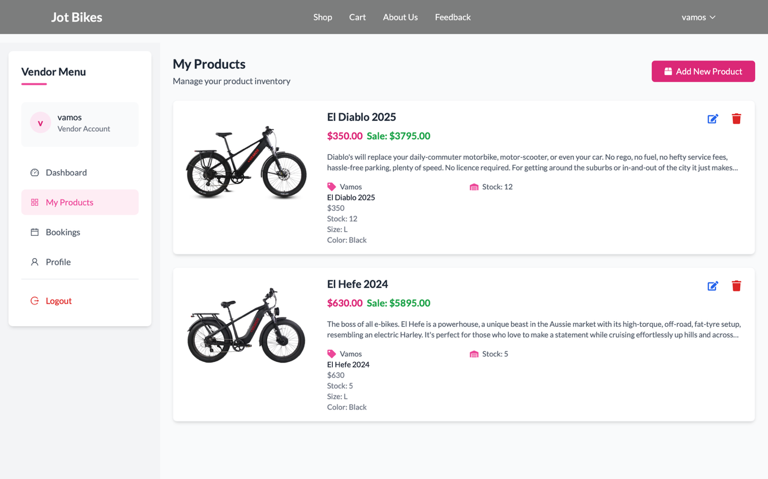

Figure : Vendor Product UI

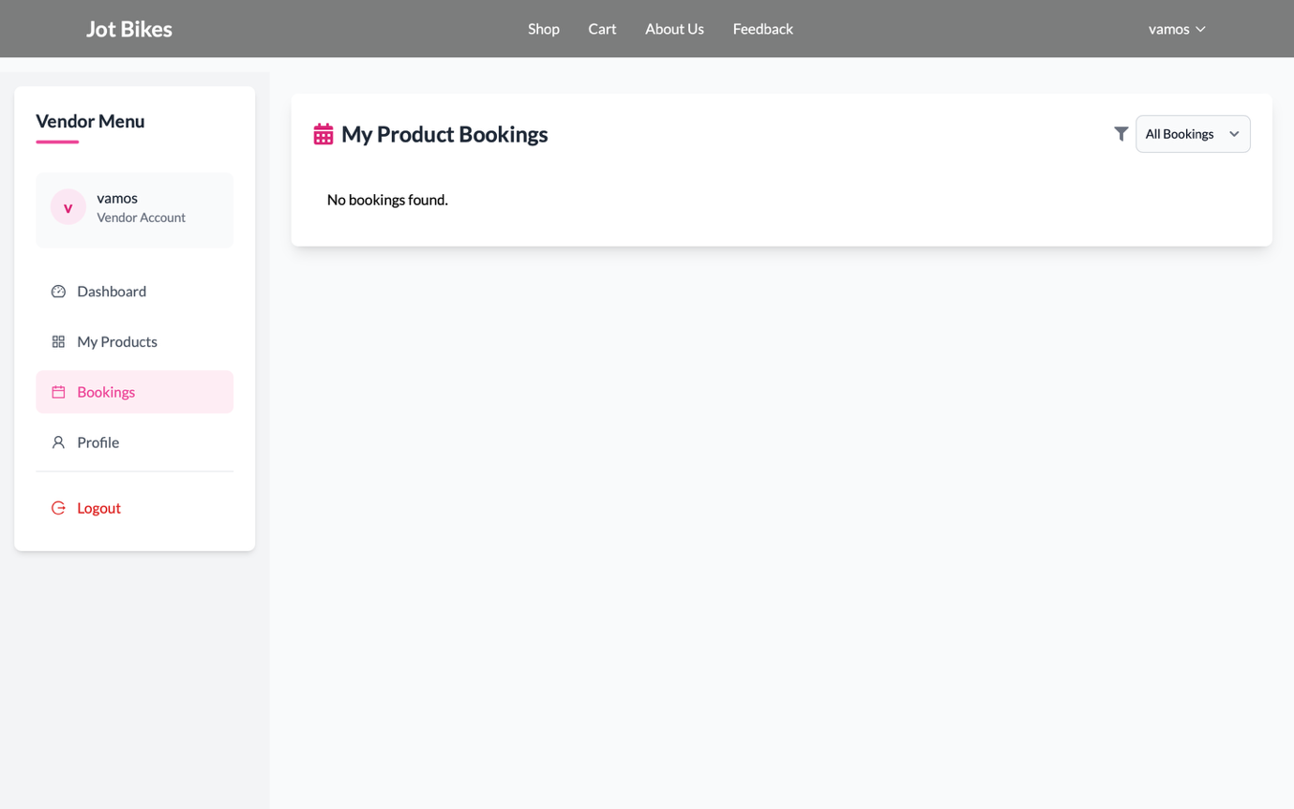

Figure : Vendor Product Booking UI

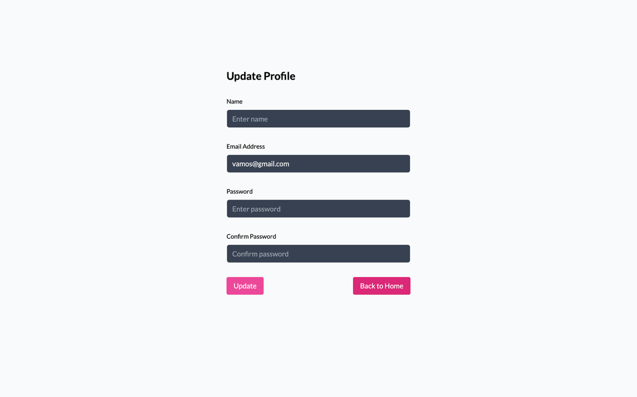

Figure : Vendor Update Profile UI

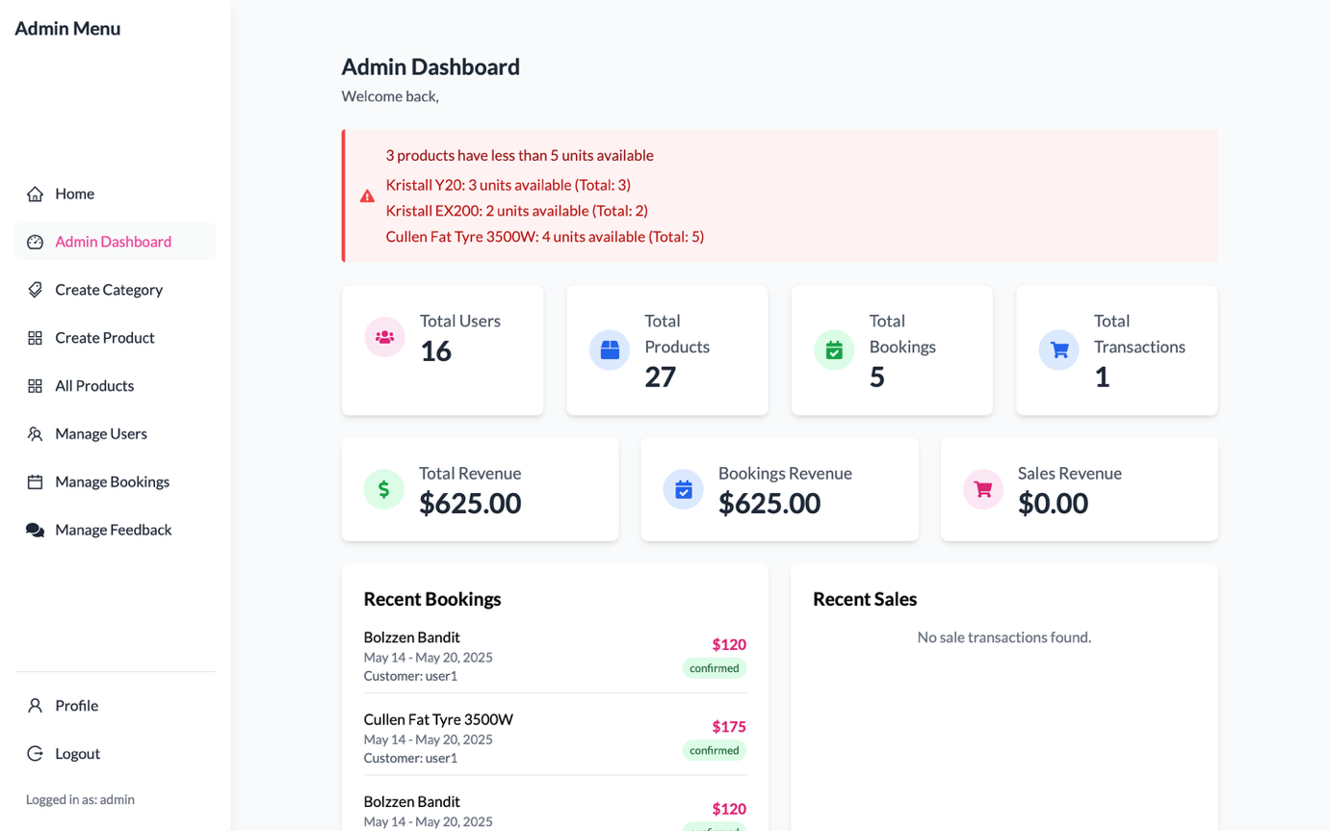

Figure : Admin Dashboard UI

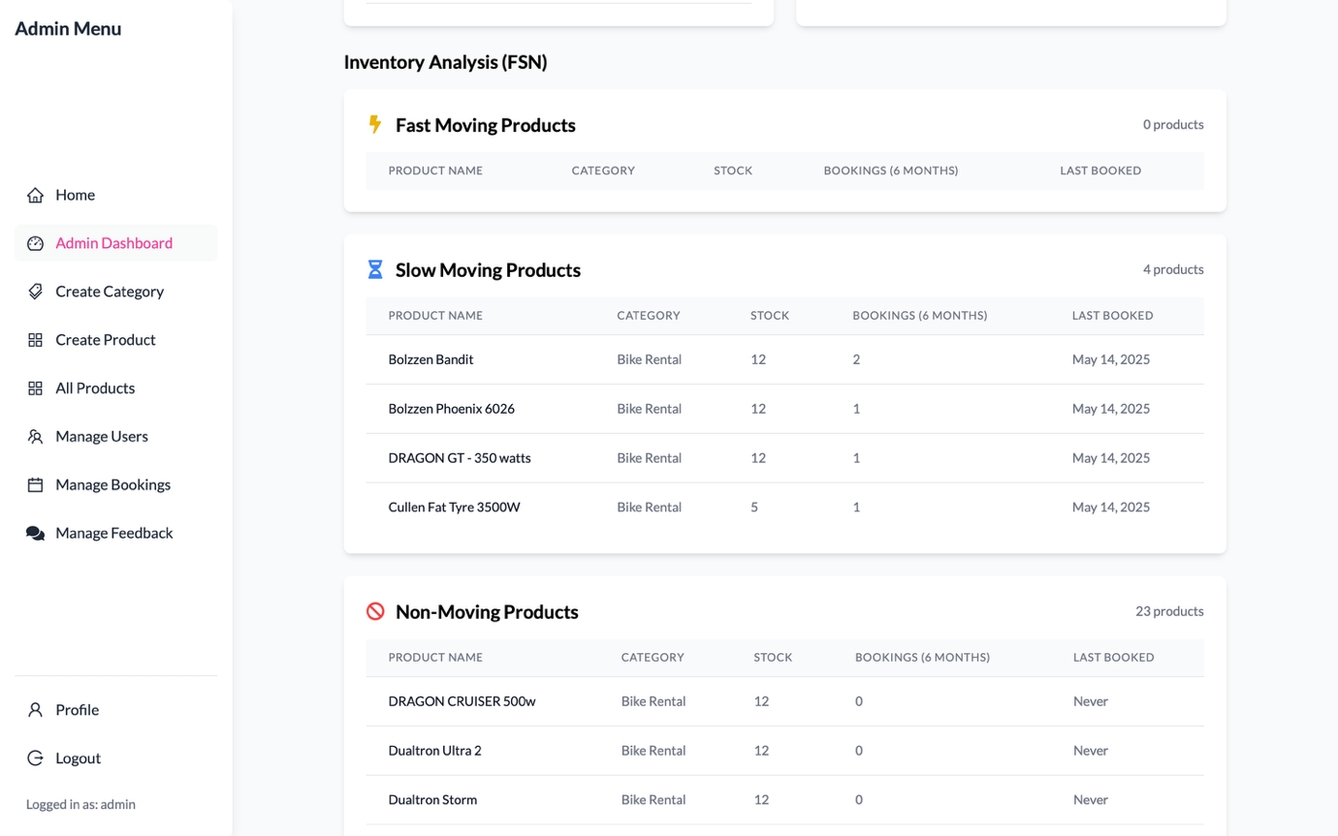

Figure : Admin Dashboard Part2 UI

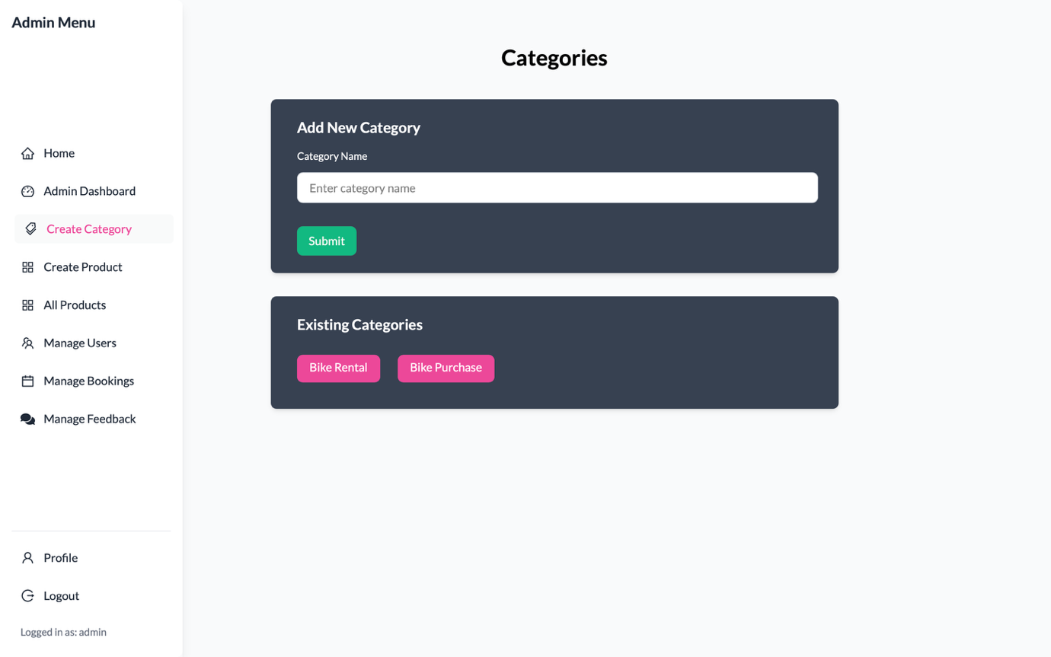

Figure : Admin Create Category UI

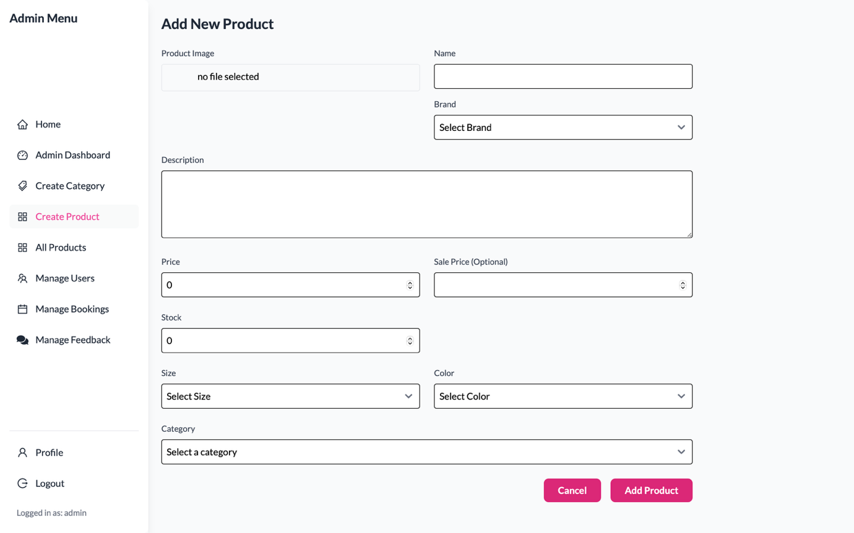

Figure : Admin Add New Product UI

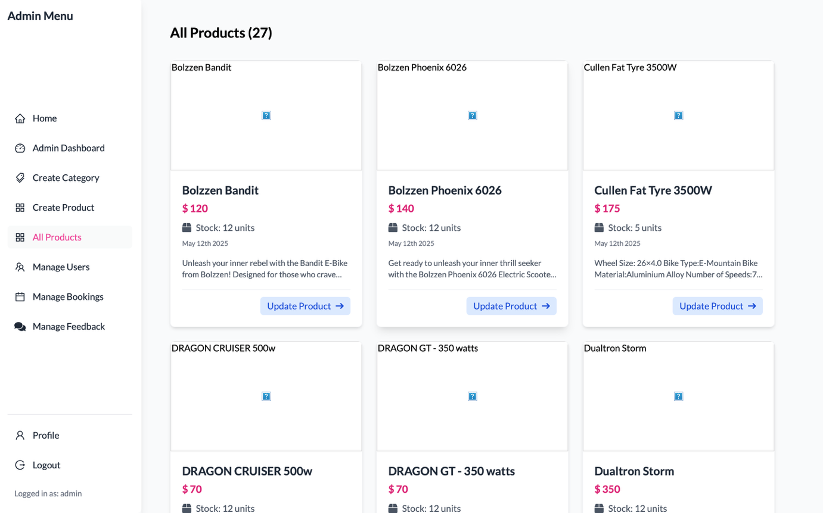

Figure : Admin All Product UI

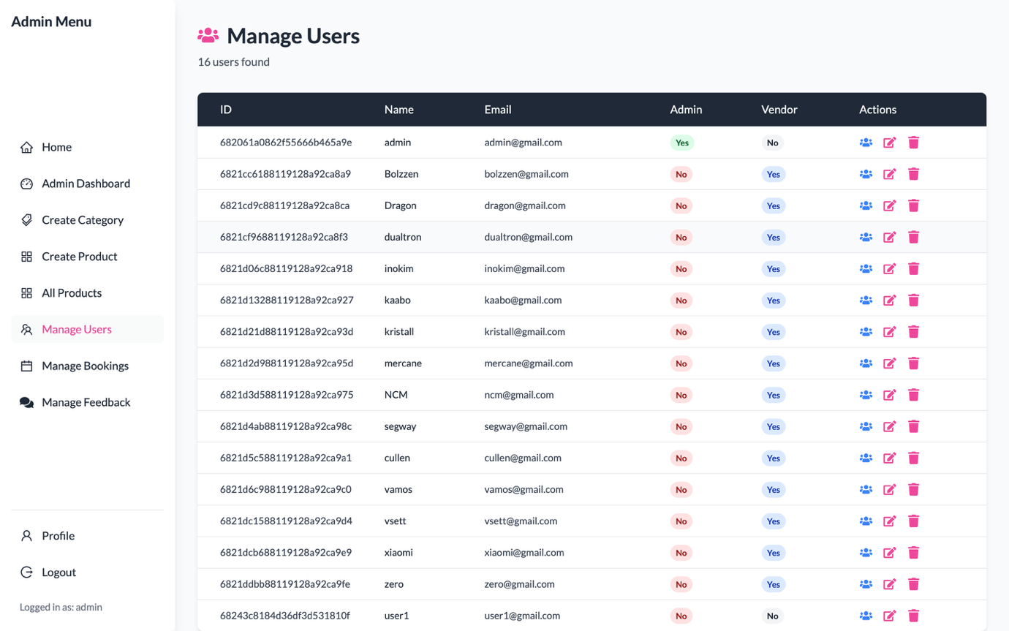

Figure : Admin Manage User UI

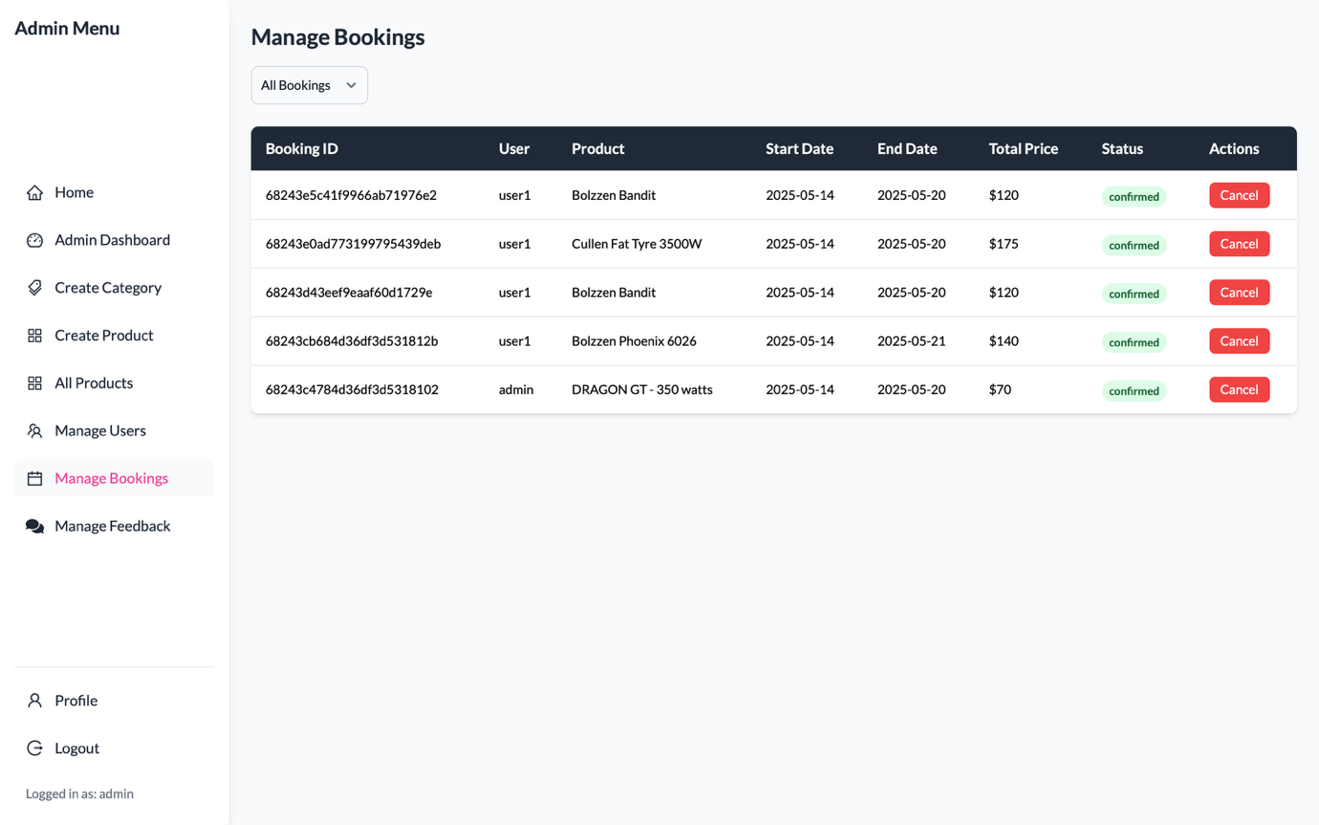

Figure : Admin Manage Booking UI

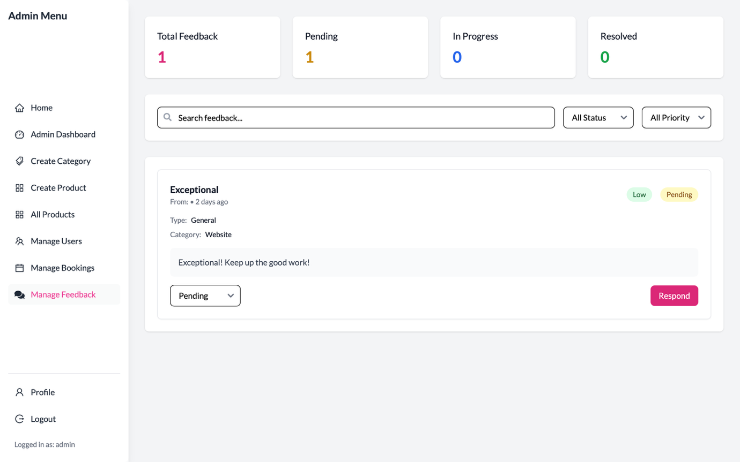

Figure : Admin Feedback Reply UI

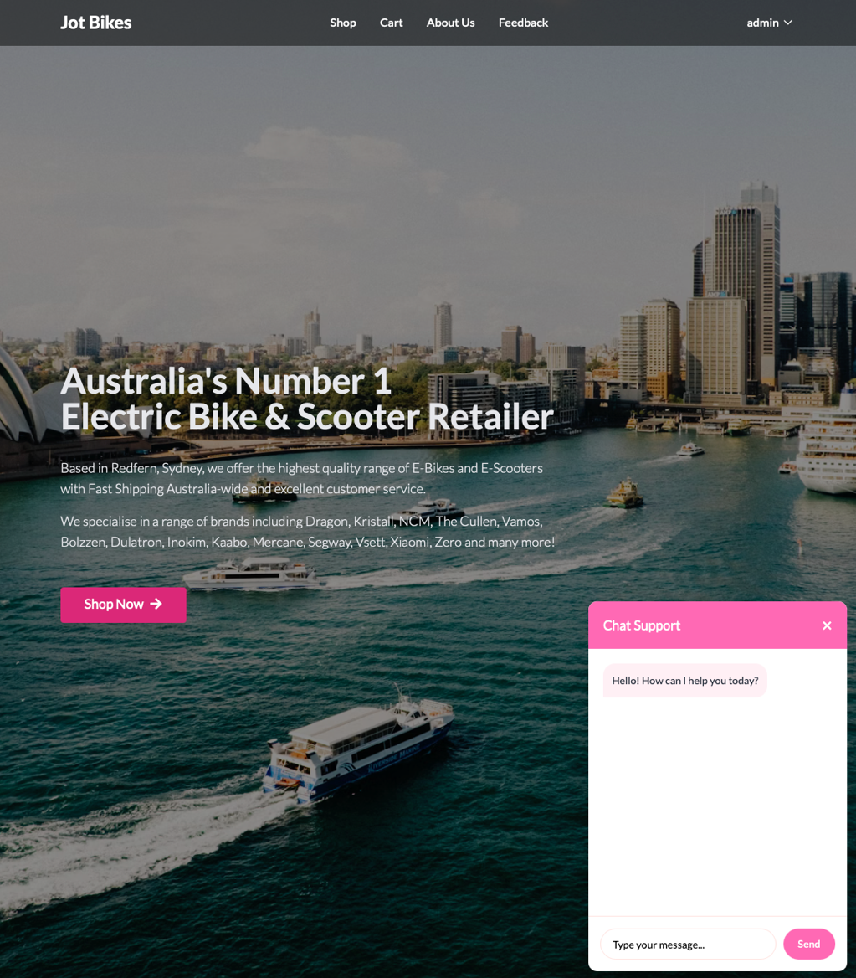

Figure : Chatbot UI

#### **User Journey**

|  |  |  |
| --- | --- | --- |
| Entity | Goal | Steps |
| Casual Rider | Book e-bike for weekend | Home -> Shop -> Product -> cart -> payment -> confirmation |
| Vendor | Add new product | Login -> Vendor Dashboard -> add new product |
| Admin | Respond to feedback | Login -> Admin Dashboard -> Feedback -> Reply |
| Customer | Ask AI for best bike size | Home -> Chat bot is at the bottom right |

#### **Chatbot UI and AI API Integration**

To enhance user experience and reduce manual support requirement, JBMS have integrated a chatbot that is powered by an AI API. The chatbot can be accessed in the home page. It has been designed to assist users with common queries such as checking bike availability, understanding the booking process, navigating the platform, it basically act as a person that you can converse with. Which is designed to improve support availability without requiring real-time human intervention.

The chatbot interface mimics the appearance of modern messaging app with automated replies. The layout has been designed to ensure fully responsiveness and styled using Tailwind CSS to match the overall look and feel of the JBMS system. The chatbot operates within a confined chat window that overlays the user’s current screen without obstructing their primary tasks.

The chatbot communicated with the AI backend through a secure API requests, with input messages passed as prompts and output returned as natural language responses (OpenAI n.d.). Error handling and fallbacks are implemented to manage failed responses or unsupported queries.

### **8. Programming and Implementation**

Jot Bikes web application is built on MERN (MongoDB, Express, React, and Node JS) stack. Styling of the page is handled with Tailwind CSS. These technologies have been chosen to follow modern practice of web development. For backend deployment we use Render, and Vercel for frontend deployment. We also use Cloudinary for hosting image uploads. For testing purposes, these free platforms are sufficient enough, however, the aim is to migrate these services to more robust solutions such as AWS and Heroku for better speed and security.

#### **Code Overview**

The code is divided into 2 parts; backend and frontend. What follows is the breakdown of the folders/files in each part with some samples of screenshots. We will start with backend.

#### **Backend Code**

Below is the overview of what folders are there in the backend.

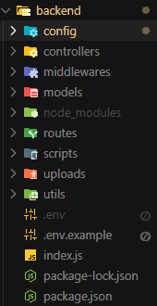

In the config folder we have:

- cloudinary.js - Cloudinary is the platform we use to host and store user uploads which mainly contain product images uploaded by the vendors or admin:

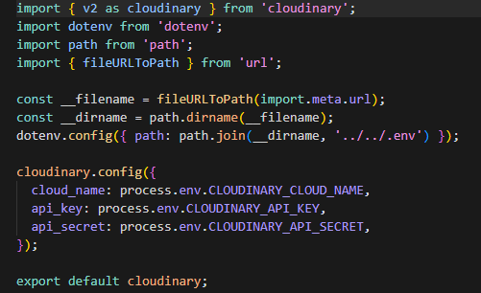

- db.js - we use MongoDB as our database management system.

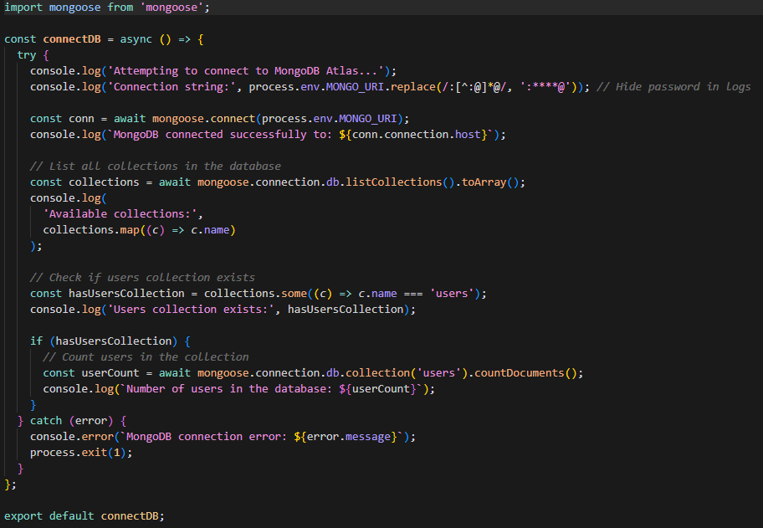

Moving on, we have controllers folder that contains the controllers for various systems in the backend, such as bookingController.js, categoryController.js, feedbackController.js, paymentController.js, productController.js, rentalAgreementController.js, transactionController.js, userController.js and vendorController.js. Below is a snapshot of userController.js file:

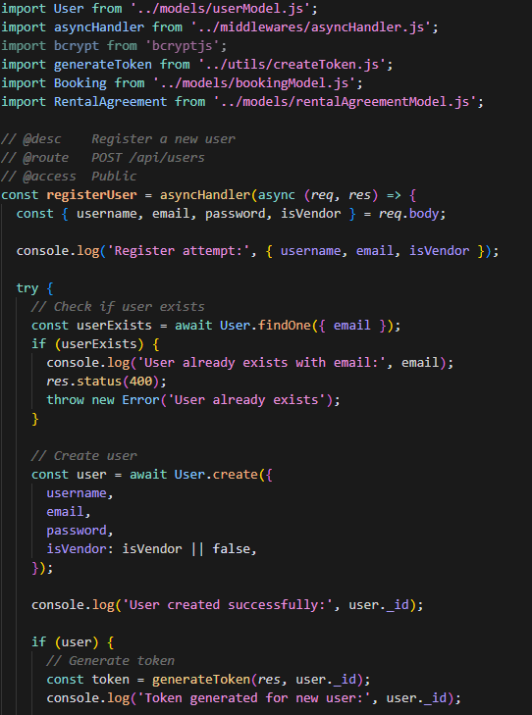

Next we have middlewares folder that consists of asyncHandler.js, authMiddleware.js and checkId.js. Below is the snapshot of authMiddleware.js:

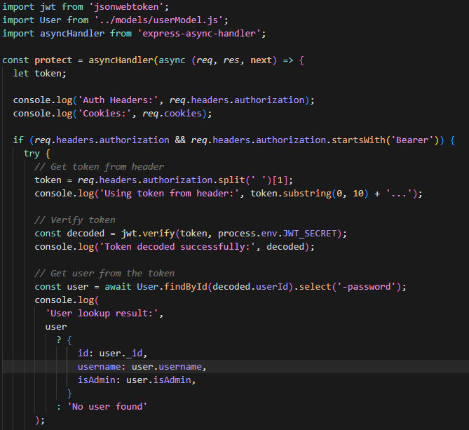

Frontend Code

Below is the overview of what folders are there in the frontend:

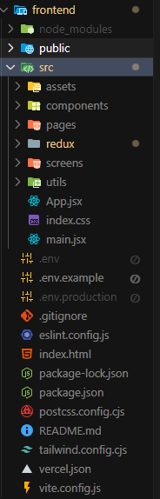

In the components folder we have quite a few files that control smaller components that make up the whole website. Below is the snapshot TopNavigation.jsx that controls top navigation menu that appears in all pages:

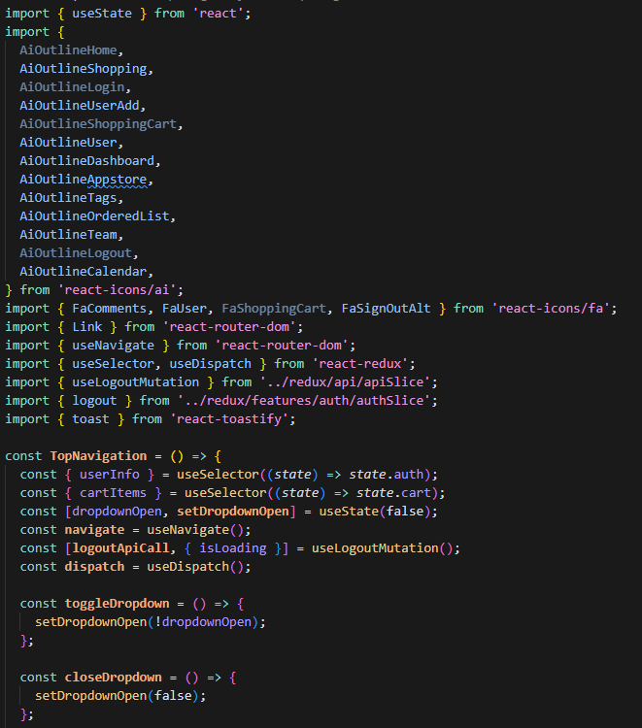

The pages folder contains all different pages on the website. For the example of pages folder, we will see the snapshot of Home.jsx that controls the homepage of the website:

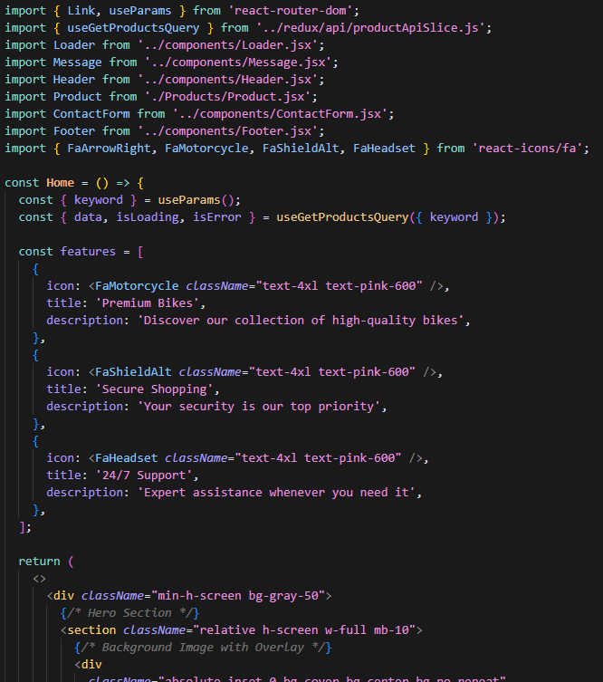

#### **Package.json File**

Furthermore, in package.json file we can see all dependencies we use to create the website:

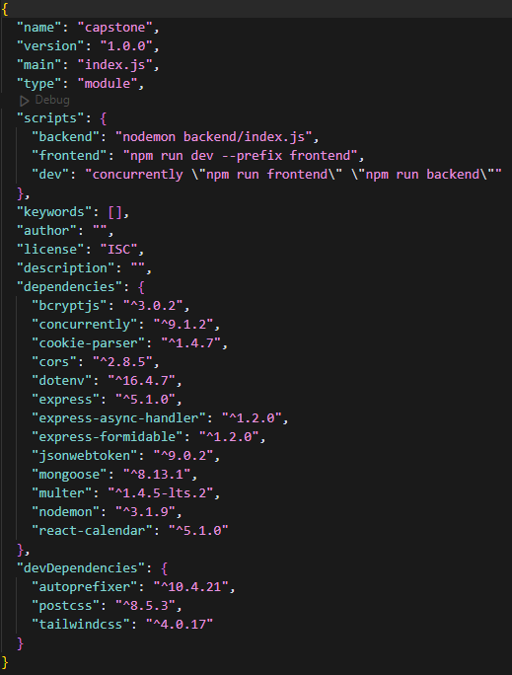

### **9. Conclusion**

In conclusion, this Systems Design & Implementation Plan demonstrates that the JBMS team has transformed well-elicited business requirements into a fully realised, production-ready web application. Through disciplined project management and collaborative development practices, we delivered a modular MERN architecture that satisfies all functional goals while upholding stringent non-functional objectives for security, performance and maintainability. A rigorously modelled MongoDB schema—exported for inspection—supports reliable data management, and a user-centred interface streamlines every core task for administrators, vendors and riders alike. The integrated OpenAI-powered chatbot elevates the platform with contextual assistance and dynamic policy training, showcasing forward-looking use of AI APIs. Comprehensive artefacts—including annotated screenshots, source code, database dumps and deployment instructions—validate each design decision and make the system straightforward to install, audit and extend. Together, these outcomes confirm that the JBMS solution not only meets the assessment criteria but also positions the client for seamless growth and continuous innovation.

### **10. Feedback**

Feedback 1: AI API Implementation can be a chatbot

Implemented a chatbot function with pending AI API integration to be work on before final deliverable.

GitHub Link to the Code: <https://github.com/erna-h33/jot-bikes>

GitHub Link to the document: <https://github.com/HendraLim1/ProjectCapstone/tree/ea501fcf6cf16b5e97ab982674921be921a8f4e0/WIP%20Report>

Website Link: <https://jot-bikes-capstone.vercel.app>

### **11. Reference**

Beck, K 2001, *Principles behind the Agile Manifesto*, Agilemanifesto.org.

Evans, E 2003, ‘Domain-Driven Design: Tackling Complexity in the Heart of Software by Eric Evans Software’.

Kopp, T, Baumgartner, M & Kinkel, S 2020, ‘Success factors for introducing industrial human-robot interaction in practice: an empirically driven framework’, *The International Journal of Advanced Manufacturing Technology*, vol. 112, no. 3-4, pp. 685–704.

Meta n.d., *React*, react.dev.

*MongoDB Courses and Trainings | MongoDB University* 2025, Mongodb.com, viewed 18 May 2025, <https://learn.mongodb.com/pages/data-modeling-toolkit>.

OpenAI n.d., *OpenAI API*, platform.openai.com.

OWASP 2024, *OWASP Application Security Verification Standard*, owasp.org.

Project Management Institute 2021, *A Guide to the Project Management Body of Knowledge : (PMBOK guide)*, 7th edn, Project Management Institute, Newtown Square, Pa.

